University of Piraeus



Bachelor’s degree Program

Department of Digital Systems

Design and Implementation of a secure SDN infrastructure

Professor in charge: Professor Panagiotis Demestichas

Student: Argyris Koudounas

Abstract

As the need for new, faster and more effective technology implementation is present, the technology industry will keep creating more advanced solutions, which can cover every case that might arise, hence advancing in fast paces and being in constant search for new ways that can change the methods we deal with existing problems, creating a variety of choices that fit specific needs.

Networks, and whatever comes along with them, are no exception. They are one of the most essential components in any organization, small or big, contributing to anything from printing a file, to authenticating the company’s users.

When it comes to them, the way most network infrastructures function has been based pretty much on the same concept: one, or more, routers are forwarding packets where they must go, based on pre-programmed algorithms inside its memory and limited remote control over it. This concept has been around for a long time, and for a good reason. But, as infrastructures increase in size and complexity, so does the effort that has to be put into maintaining them and the need for simplicity in their control.

Therefore, designing and managing all those network nodes could become a huge hustle, even for the most experienced administrator.

This is where Software Defined Networking comes to play, a new network infrastructure design that is based on one thing: centralized control. By using one main node to control all the network functions across the infrastructure, called a controller, system centralizes the network control into one place, making managing, monitoring and implementing new things much easier. From controlling where and how traffic flows through the network, to monitoring and retrieving logs from each network node, are all done by the controller, through protocols created specifically for this kind of infrastructure.

Of course, no new solution comes without a good deal of pros and cons. In this thesis, we will try to analyze those pros and cons, the issues an average user might face when he, or she, starts getting into the whole SDN ideology, and the different solutions that can be implemented in order to deal with the targeted issues. At the same time, I will also try to compare SDN with legacy network functions, so we can have a better picture of all the things I mentioned before.

The purpose of this thesis is to research the idea behind the theory of software defined networking, mainly as a new type of network infrastructure, while locating its flaws when it comes to security. At the same time, this thesis would also like to present the results of implementing legacy network security tools on such networks, in order to see how they behave on SDN and how issues that might appear could be tackled. Τhe research that occurred was:

* Research on the functions of SDN and plane-separated infrastructures
* Research on security tools that could be, theoretically, applied on a software defined network infrastructure
* Solutions to simulate and study a software defined network infrastructure
* Solutions to simulate examples for attacks in a software defined network infrastructure
* Research on the effective integration of SDN and legacy security tools.
* Implementation of a sophisticated IPS, in order to enhance security in SDN infrastructure.

Through this research and testing, I hope to come to a solid conclusion about SDN, its security, its implementations and all the solutions that can be used on the targeted issues.

More specifically,

In Chapter 1 I introduce you to SDN and network security, the main subjects of this thesis.

In Chapter 2 I analyze more in-depth the history and structure of SDN.

In Chapter 3 I showcase OpenFlow, they protocol that makes most controllers function, from sending data to switches to creating and maintaining flow lists.

In Chapter 4 I get into more detail about Mininet, the software that helped me emulate my SDN infrastructure, and a variety of open-source controllers available to anyone.

In Chapter 5 I analyze into detail the software structure of legacy networks, security in legacy networks with a focus in IDS/IPS, and security in every part of an SDN infrastructure.

In Chapter 6 I showcase the idea behind the experiments I conducted, the tools I used and a rough guide of how I installed and used them properly.

In Chapter 7 I analyze the results of my experiments, and how each attack and security tool affects the SDN infrastructure I have set up, while reviewing data from the controller and the virtual network.

Acknowledgments

I would like to deeply thank professor Panagiotis Demestichas for the opportunity he gave me to get into network science and work more on it, through his lectures and help, while trusting me and assigning me with this subject for my thesis.

Additionally, I would also like to express my gratitude towards Mr. Mihalis Mihaloliakos, for the help and coordination throughout this project. Thanks to his guidance and long skype calls, I managed to overcome all the obstacles I was facing and completed my thesis, while fully understanding the subject.

Finally, I would like to express my deep thanks to my family, who supported me and were there for me whenever I needed them. Without them, I would never be where I am right now.

Table of Contents

*Abstract* 2

*Acknowledgments* 4

Table of Contents 5

1. Introduction 8

1.1. SDN (Software-defined networking) 8

1.2. Network Security 8

2. SDN Analysis 9

2.1. History of SDN 9

2.2. OpenFlow 10

2.3. Infrastructure 10

2.3.1. Software 11

2.3.1.1. Application Plane 11

2.3.1.2. Control Plane 11

2.3.1.3. Data Plane 12

2.3.1.4. Control-Data-Plane Interface (CDPI) or Southbound Interface 12

2.3.1.5. Northbound Interface 12

3. OpenFlow Analysis 13

4. SDN Controllers: Information and Comparison 15

4.1. Mininet 16

4.2. Open vSwitch 17

4.3. Project Floodlight 18

4.4. NOX/POX 19

4.5. Ryu 20

5. Security in Networks & SDN 21

5.1. Legacy Networks Basics: The OSI model 21

5.1.1. Physical Layer 22

5.1.2. Data Link Layer 22

5.1.3. Network Layer 23

5.1.4. Transport Layer 23

5.1.5. Session Layer 23

5.1.6. Presentation Layer 23

5.1.7. Application Layer 23

5.2. Legacy Networks Security: The OSI security architecture 23

5.3. Legacy Networks Security: Categories of attacks 24

5.3.1. Passive Attacks 24

5.3.2. Active Attacks 25

5.4. Legacy Networks Security: Mechanisms and Services 27

5.5. Legacy Networks Security: Intrusion Detection/Prevention Systems (IPS/IDS) 28

5.5.1. IDS approaches 29

5.5.2. IDS vs IPS: What is the difference? 31

5.6. Legacy Networks Security: Firewall 31

5.7. Security in SDN 32

5.7.1. Application Plane Security 33

5.7.2. Control Plane Security 34

5.7.3. Data Plane Security 35

5.7.4. Northbound and Southbound Interface Security 36

6. Project Idea and Execution 37

6.1. Project Idea 37

6.2. Tools 38

6.2.1. VMware Workstation 38

6.2.2. SDN Hub VM with Mininet 39

6.2.3. Snort 39

6.2.4. Firewall (iptables) 40

6.2.5. Python SnortIPS script 40

6.3. Execution 40

6.3.1. Part one: Installing VMware Workstation and SDN Hub VM 41

6.3.2. Part two: Downloading and Setting up Snort 42

6.3.3. Part three: Setting up Snort rules and IPS mode 44

Downloading and implementing Rules 44

Rules Analysis 46

IPS Mode 49

6.3.4. Part four: Using Mininet with native controller and Ryu 51

Installation 51

Usage and commands 53

Using a remote controller - Ryu 54

6.3.5. Part five: Firewall set up and rules 55

Blocking and accepting Traffic 57

Listing, deleting and replacing rules 58

6.3.6. Part six: Python SnortIPS script 59

7. Simulations and Examples 63

7.1. Example 1: Snort IDS mode 65

1st case: ICMP Flooding 65

2nd case: TCP ACK header flooding 67

3rd case: TCP SYN DoS Attack 68

4th case: Nmap XMAS and NULL port scan 70

7.2. Example 2: Snort IDS mode & Linux Firewall rules 74

1st case: ICMP Flooding 74

2nd case: TCP SYN DoS Attack 76

3rd case: Nmap port scans 78

7.3. Example 3: SnortIPS Program 81

1st case: ICMP Flooding 81

2nd case: TCP SYN DoS attack 83

3rd case: Nmap Scan 85

8. Conclusion 88

9. References 89

10. Table of Figures 91

1. Introduction
   1. SDN (Software-defined networking)

Software-defined networking (SDN) technology is an architectural approach that has the purpose of centralizing a network’s control, giving remote access to any network node that is responsible for packet forwarding. This creates more flexible, and easily monitored, network infrastructures that enable more efficient network configurations, followed by improved performance.

The issue this technology wants to address is the fact that traditional networks are decentralized and complex, needing extra time to have someone deal with various problems that can show up in them, while there is a need for flexibility and easy troubleshooting, as networks grow bigger and more complicated.

Computer networks can be separated in 3 parts, according to their function: the data plane, control plane and application/management plane. In typical, or “legacy”, networks, those planes are bound together in a single networking device, making the network infrastructure work in a decentralized way, where each packet is routed and forwarded through the usage of a router in the network. SDN, on the other hand, focuses on centralizing network intelligence in one network component by separating the forwarding process of network packets (data plane) from the routing process (control plane). The control plane consists of one or more controllers which are considered as the brain of SDN network where the whole intelligence is incorporated, while the data plane consists of several switches, that forward packets according to the “instructions” the controller, or controllers, give them.

Administratively, a network engineer or administrator can shape and manipulate traffic from a central control console without having to come in contact directly with individual switches in the network, saving him time and resources, compared to a decentralized infrastructure, where the engineer would have to execute specific actions for each device. The centralized SDN controller directs the switches to deliver network services wherever they're needed, regardless of the specific connections between each network node.

However, this kind of centralization has its own drawbacks, especially when it comes to security, scalability and elasticity, with security being the main, and most scalable, issue of SDN I will address in this thesis.

* 1. Network Security

Since the usage of networks became widespread and the volume, and importance, of data that got transported started increasing significantly, the need for protection increased.

Companies and organizations delivering services want to make sure their infrastructures, employees and customers are protected from any threat that can compromise data, and reputation. That’s where network security pops in, ensuring information is safe from attacks.

Network security is any activity, or practice, designed to prevent and protect the integrity of networks and data, against unauthorized access. It utilizes both hardware and software technologies, combining multiple layers of defenses at the edge and in the network, implementing policies and practices adopted to prevent and monitor intrusions, misuse, data and network modifications, or denial of a computer network resource.

Some brief examples of network security concepts could be 1) access control 2) anti-malware 3) packet behavior analysis (behavioral analytics) 4) firewalls 5) intrusion detection and prevention

With this concept in mind, a well-adjusted team of security administrators can keep a network, it’s nodes, and its data safe, by monitoring and securing it with access control, anti-malware systems, firewalls and intrusion prevention systems, covering all the vulnerable nodes, while keeping the whole solution cost-effective, based on company or organization finances, and simple.

1. SDN Analysis
   1. History of SDN

The history of SDN can go all the way back to the public telephone network, where the separation of control and data plane was first implemented to improve management.

In 2004, the Internet Engineering Task Force or IETF, began thinking of new ways to separate the control from the forwarding functions in a network. Hence, they published an interface standard called "Forwarding and Control Element Separation" (ForCES). Other standards, like the ForCES, include the Linux Netlink, which was an IP service protocol.

The whole idea did not gain too much favor at the beginning, mostly because the internet community viewed the idea of separating the control plane from the data plane as very risky, but also because manufacturers thought that this separation, and the creation of APIs between the planes, would create lots of competition.

The use of open source software in this architecture was the starting point that would start bringing more friction for the SDN idea. That’s the point where OpenFlow first came to be, as a result of Ethane project, from Stanford University’s computer science department.

Work on OpenFlow continued, while tests were run on one campus network and on a WAN that connected multiple campuses.

In 2008, an API for OpenFlow was developed, and later the same year NOX was created; an OS for networks.

In 2009, Hewlett-Packard and NEC created a few SDN networks based on OpenFlow, for research and production.

Outside academic research and production, Nicira started the first developments to control Open vSwitches (OVS) from Onix, a distributed system that handles the distribution and collection of information from switches, in collaboration with NTT and Google.

In 2011, the Open Networking Foundation was created, to promote SDN and OpenFlow.

In 2012, Google started its own development, with B4, and later acknowledged their first OpenFlow projects with Onix.

In 2014, at Interop and Tech Field Day, SDN was demonstrated by Avaya, using the IEEE 802.1aq standard and OpenStack, showing automation in all planes and no need for manual labor for the service to work [2]

* 1. OpenFlow

OpenFlow is a communication protocol, created by the Open Networking Foundation (ONF), which allows the communication of a SDN controller with a network switch, in order to determine specific paths packets will follow.

In SDN networks, controllers and switches are separate network components, in order to create easier and more sophisticated network monitoring and management, using Access Control Lists and other routing protocols.

Residing in an SDN controller, the protocol is responsible for the routing of all the packages across the network. It is technically the “brain” in an SDN infrastructure, allowing the remote administration of the Network layer (3rd Layer) packet forwarding tables in a switch, by manipulating the switch’s configuration state and flow tables, as well as taking actions based on specific switch events.

OpenFlow is universal, meaning that it can be used on switches from different vendors, with different scripting languages and interfaces, and is layered on top of the Transmission Control Protocol, or TCP, typically listening on TCP port 6653 for switches requesting connection. [3]

This is a brief overview of OpenFlow, for the purpose of understanding how an SDN works, and it will be analyzed further in later chapters, specifically on chapter 4.

* 1. Infrastructure

Like a “legacy” network infrastructure, an SDN infrastructure is consisted of several networking devices and equipment, like routers and switches. The main difference here is that in a SDN, all this equipment is now used only to forward traffic around the network, since the control of where this traffic goes is no longer up to them, but to a centralized controller, that is responsible for instructing those devices how their data plane will work, hence the way the control and data forwarding functions are separated, in order to provide better remote management and monitoring.

This is called “disaggregation” and is what defines an SDN structure.

SDN architectures are defined by 3 planes/layers of functionality, together with 2 interfaces which connect those planes, mentioned bellow.

* + 1. Software
       1. ****Application Plane****

This part of the SDN architecture consists of the SDN applications, which are software programs targeted to perform functions like the ones executed by the firmware in conventional network devices. As I mentioned before, control over the network functions is separated from the hardware and executed by applications and special software. Such applications consist of one SDN Application logic and one, or more, Northbound Interface Drivers (NBI). The NBI is the interface that connects the SDN apps with the controller, in the control plane, where network behavior commands and events are exchanged. For an NBI driver to work, there must be an NBI agent with which it will be paired with.

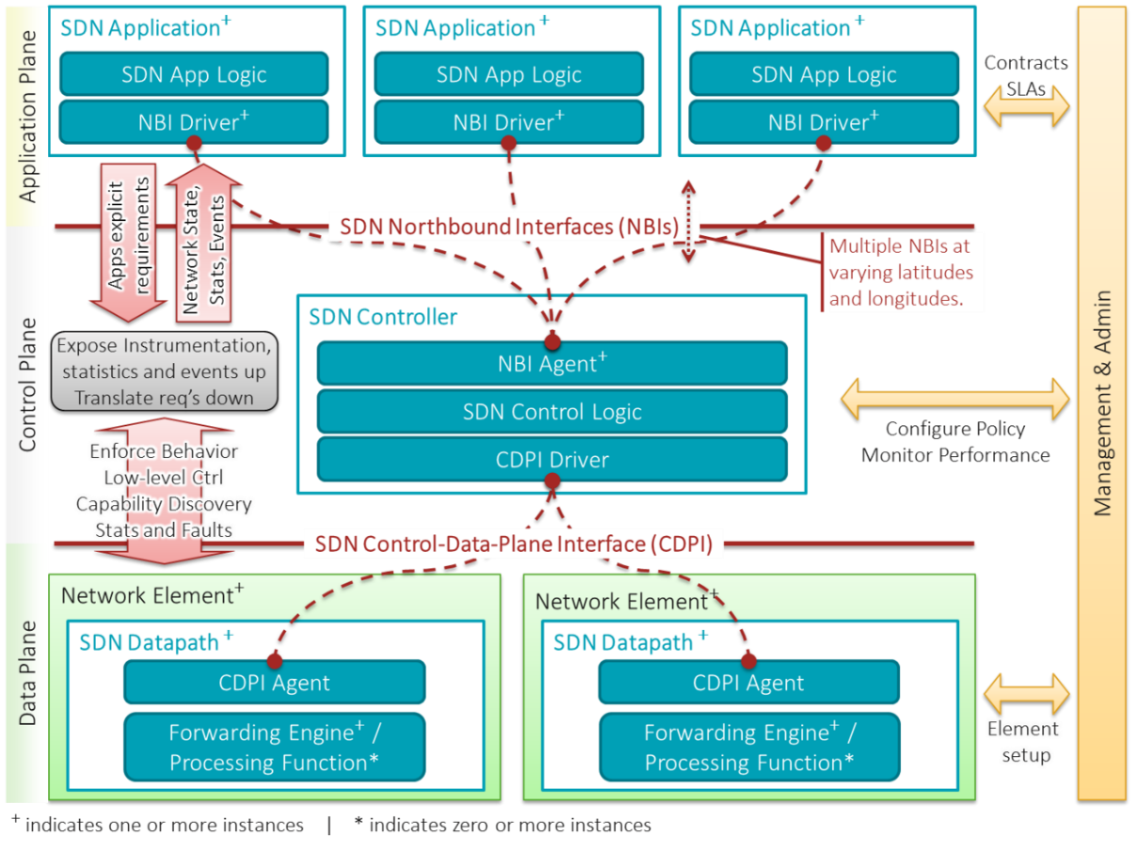

Figure 1 SDN Structure and functionality

* + - 1. ****Control Plane****

Since there is a need for constant communication between the Application plane and the Data plane, the Control plane does exactly that, linking those two planes together. This is also where the SDN controller is located. The controller is in a constant communication with the Application plane, through the NBI agent, getting commands and instructions from high-level applications, which will be used on the networking devices in the rest of the network.

The controller receives instructions from the upper layer in the form of rules, which are then forwarded on the network switches and are responsible for their packet forwarding functions. Those rules can be constantly updated by the Application layer, in case there is the need for a new configuration.

At the same time, the controller receives data from the Data plane, like statistics, network changing events etc., through the Control-Data plane Interface (CDPI) driver, which are forwarded in the Application plane. Like the NBI, CDPI is responsible for the link between the controller and the network devices, if the CDPI agent located in each one of them reports their status.

Regarding the controller itself, there are many options out there to choose from, which offer different ways of tweaking your network, programmed in many programming languages, but following the same basic principles. We will discuss those more in-depth later.

* + - 1. ****Data Plane****

The data plane handles incoming datagrams (on the wire, fiber, or in wireless media) through a series of link-level operations that collect the datagram and perform basic sanity checks. A well-formed (i.e., correct) datagram is processed in the data plane by performing lookups in the forwarding information base table (or tables, in some implementations) that are programmed earlier by the control plane. This is sometimes referred to as the fast path for packet processing because it needs no further interrogation other than identifying the packet’s destination using the preprogrammed forward information base. The one exception to this processing is when packets cannot be matched to those rules, such as when an unknown destination is detected, and these packets are sent to the route processor where the control plane can further process them using the routing information base. [5]

* + - 1. ****Control-Data-Plane Interface (CDPI) or Southbound Interface****

The Southbound Interface, or Control-Data Plane Interface, is an API that efficiently provides control over the network, allowing the Controller to function in real time and communicate with the network nodes responsible for traffic. One of the most popular Southbound APIs is OpenFlow. It is a standard API that allows the controller and the nodes, responsible for forwarding network traffic, to interact, so flow tables on the OpenFlow switches can be manipulated, by the controller, in real time. This includes adding, removing and changing flow rules on them, according to the network needs. Another famous API that is widely used is Cisco’s OpFlex. [6]

In general, Southbound Interfaces, or APIs, are the connection between the controller and the forwarding nodes inside the network infrastructure, thus increasing the element of centralized control and the separation between it and the data plane. Even though these APIs are virtual, they still rely heavily on the nodes they refer to. [4]

* + - 1. ****Northbound Interface****

The Northbound Interfaces are Rest APIs used for communication establishment between the network applications on the Application plane and the SDN controller.

These APIs are important components on an SDN infrastructure, since the whole SDN philosophy is based on user interaction with the network, through applications directly communicating with the controller. Because of its important role, these APIs must support a big variety of applications, in order to create a hustle-free environment and make sure most, if not all, applications of this kind will be compatible with it. Of course, because it is impossible to create a “one size fits all” solution for such a big amount of different applications, there is a big variety of Northbound APIs out there to cover different applications. [43]

1. OpenFlow Analysis

In this part of the report, Ι will further analyze what is OpenFlow, how does it work, and the history behind the legend.

At the beginning, OpenFlow was implemented as part of network research, at the University of Stanford, with the purpose of creating experimental protocols for campus networks that could be used for experimentation and research. Before that, each university had to develop their own experimentation platforms. After the idea of OpenFlow was created, there was the theory that it could take the place of the functionality of protocols in Layer 2 and 3, in switches and routers. In 2011, a group of service providers created the Open Networking Foundation, or ONF, a non-profit association focused on promoting, commercializing and standardizing OpenFlow in networks. In order to achieve this, the ONF has a very dynamic marketing section, which promotes OpenFlow, along other SDN related things, hosting annual conferences as well. [5]

Like Ι mentioned before, OpenFlow is the working muscle behind every controller action, enabling it to determine the path network packets will follow in a network. It runs over TCP and supports SSL for all the connections between the controller and the network switches.

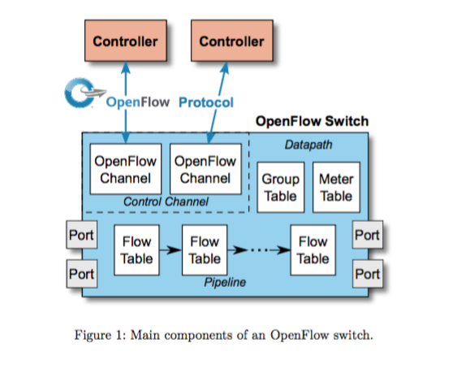

Figure 2 OpenFlow Switch Components [7]

For a network switch to support OpenFlow, or OF, it is required to contain the following components, shown in Figure 2:

* **OpenFlow Channel**, through which a connection with one or more controllers can be established. After connection is established, the controller manages the switch, via the OF protocol.
* **Flow Tables,** which contain flow entries, manipulated by the controller. Based on those entries, the switch can forward or lookup packets.

A flow entry contains parameters like 1) match fields, 2) counter and 3) actions/modifications to be applied for matching packets.

* **Pipeline processing instructions** allow packets to be processed by or be sent to different flow tables for further processing.
* **Group Tables** contain group entries, which contain action buckets. Those include a set of actions, like flooding, multipath forwarding or flow entries definitions for similar actions (for example, multiple flow entries performing the same action).
* **Ports**, refers to a physical port. However, it may refer to logical port specified for a loopback interface or reserved port specified for forwarding actions like sending packets to the controller.

The way the model of OpenFlow works has been connected to how SDN, in general, works. This means that, it includes 1) different planes for control and data functionalities, 2) all components in the network use standard protocols for communicating and forwarding traffic and 3) APIs that can offer programmability over the network.

In the following example, we will see how OpenFlow protocol works, and how each one of a Software Define Network components cooperate to move traffic around.  
We will consider a network of one controller (C0), an OpenFlow Virtual Switch (S1) and 4 hosts (H1, H2, H3, H4), as seen in Figure 3. We will follow the scenario where host H1 acts as an HTTP client, sending a HTTP request to H4, who is a simple HTTP Server.

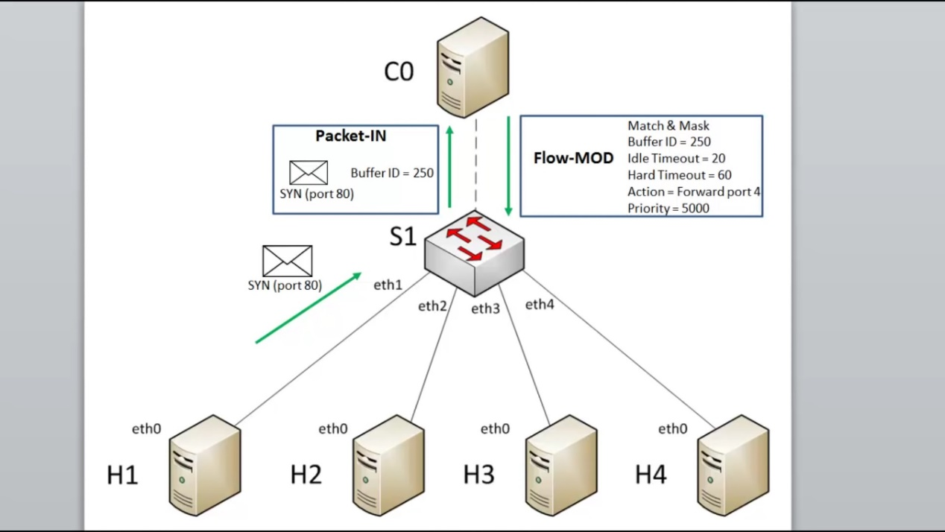

Figure 3 A software defined network example [8]

In this scenario, the following steps occur:

1. H1 send SYN message packet to H4 (since this is a TCP conversation)
2. S1 checks its Flow Tables for a flow referring to such connection. Since it won’t find such entry, which matches the SYN packet, it will send it up to the controller (This is called a Table Miss).
3. S1 sends a “Packet-IN” message to the controller, which includes parts of the SYN packet mentioned before, and a unique reference buffer ID
4. C0 receives the message and either sends a “packet-Out” message, which contains a simple entry of the action the switch should apply (In this example, to forward the SYN message to port “4” (eth4), where H4 is connected) or sends a Flow Modification message to the switch. The Flow-MOD installs a flow entry at one of S1’s flow tables telling the switch to treat similar requests in a specific way. In this example, the controller instructs the switch that any TCP port 80 requests from the IP and MAC of H1 to the IP and MAC of H4 to be sent out of port 4.

It includes 1) the reference Buffer ID of the packet, 2) idle timeout (if the flow entry does not match a packet, delete after set time), 3) hard timeout (after set time, flow entry is deleted no matter what), 4) action, 5) priority (in case packet matches more than one flow, use one with highest priority)

1. After flow entry is installed, S1 forwards the SYN message through port 4, to H4
2. SDN Controllers: Information and Comparison

The three most important and distinct characteristics of SDN are centralized control over the network, programmability, and the separation of control and data into two separate planes. The SDN is the embodiment of the idealized SDN framework, and in most cases, reflects the framework. [5]

Like I mentioned in previous parts of this paper, a SDN controller is the “brain” of a software defined network, being a central application that is responsible for the flow control management in switches or routers and acting as the “middle man” between them, and the application layer controllability.

Controllers usually run on a server and use specific protocols (like OpenFlow) to communicate with switches or routers.

A controller’s job typically is to direct traffic depending on policies that a network operator has placed and distributing them to all connected nodes in the network. This way, the control plane is removed from each individual network device, making it easier for centralized and integrated network management. So, practically, the SDN controller could be considered like an operating system, operating the network.

The most popular SDN protocols used by controllers to communicate with network nodes, like switches and routers, are OpenFlow, OpFlex and OVSDB. Other protocols are in development, while already existing protocols are being modified to run on SDN networks correctly and efficiently. Examples of such configured protocols are OSPF, BGP, IS-IS and MPLS, which became available to SDN controllers by a standard that allows them to use those protocols. [11]

In the following sections I will analyze a few open source controllers, available for anyone to download them.

* 1. Mininet

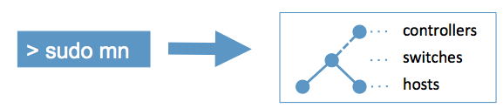

Figure 4 Mininet Logo [11]

Before I go ahead with my analysis of all the different controllers available out there, I should begin with the application in which most of them can be emulated – Mininet. Mininet is a network emulator, which can emulate most of the components found in an SDN infrastructure. It can create multiple virtual hosts, links, switches and controllers, all on a single Linux kernel. Spawned switches support OpenFlow, so they can be used for SDN purposes, and each host has its own CLI to be controlled with, making it behave like an actual machine, which runs its own programs, connected to the network infrastructure.

One very important feature Mininet includes, that makes it so good for experimentation, is that it lets you create and spawn custom topologies, from simple 4 hosts-2 switches topologies, to complex Internet-like ones, that are used for BGP research. Mininet also allows the user to fully customize the function of packet forwarding, with a little bit of tweaking.

Mininet utilizes Open vSwitch switches and controllers by default, but also supports other controllers, if those are defined by the user. We will see how this is done in later chapters.

Additionally, a few of many pros Mininet generally offers are:

* Mininet is very lightweight, making ideal to be used on almost any computer.
* It is cost-effective, since every single network element can be virtualized and emulated in a single machine.
* It is ready to use from the moment it is downloaded and installed, without any extra programming.
* Mininet orchestration is done in Python, therefore it offers a Python API for network tweaking.
* It has a huge scalability, offering the ability to create a vast number of network nodes, with big bandwidths.
* It can be installed very easily, can be reconfigured and restarted fast and is always available.
* Can interact with any real network.

All these make Mininet an ideal tool for research purposes, which anyone can install and use.

The only limits Mininet has are two and are predictable. First, a Mininet network cannot exceed the power and speed of the computer it is run from, and second, Mininet cannot run on non-Linux network machines. [5][11]



Figure 5 A visualization of a simple Mininet Network [5]

* 1. Open vSwitch

This is the default controller Mininet supports, since it provides OVS switches and OVS controllers, if a remote one is not specified. Open vSwitch, or OVS, is and open-source distributed virtual multilayer switch, which can function both as an SDN switch, inside a virtual machine, and as a controller, controlling switches inside a software define network infrastructure. It is utilizing VM Hypervisor, a computer software/hardware/firmware that allows the creation and running of virtual machines, in order to fulfill its switching and control functions, of which it supports many like VirtualBox and Xen hypervisors and Hyper-V ports. This makes it more than ideal to work in virtual machine environments, hence its usage in Mininet. Apart from its VM capabilities, Open vSwitch was designed to also function with physical servers, allowing distribution across multiple of them, as seen in Figure 6.

Most of its code is written in C, and its environment can easily be migrated to other environments. Other features than are supported are 802.1ag connectivity fault management, OpenFlow 1.0 and its extensions, usage of Linux kernel modules, Quality of Service (QoS) configurations and many more.

The main components of Open vSwitch are:

* ovs-vswitchd: implements the switch and its functions in Linux
* ovsdb-server: switch configuration database
* ovs-dpctl: switch kernel configuration tool
* ovs-vsctl: query and update tool for ovs-vswitchd
* ovs-appctl: command tool for running Open vSwitch
* ovs-ofctl: control tool for OpenFlow switches and controllers
* ovs-pki: tool for public-key infrastructure creation and management

[13][14]

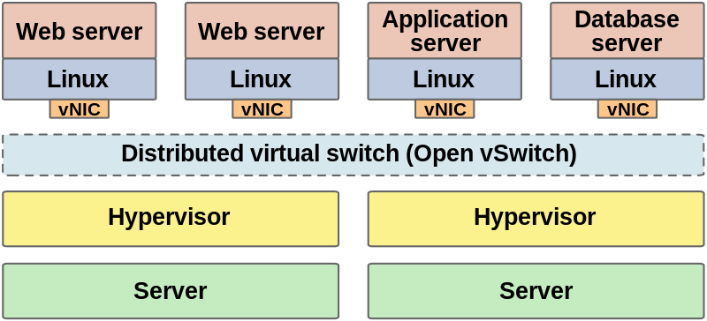

Figure 6 Open vSwitch deployed as a cross-server network switch [14]

* 1. Project Floodlight

Project Floodlight is an open source SDN controller, based in Java and licensed by Apache, which was developed by a community of developers called Big Switch Networks, alongside other, independent developers.

Since it is supported by such a big community of developers, it has been tested multiple times, both in physical and virtual networks, and can get the business done in both cases. One very interesting characteristic with this controller is that, it’s one of the few network controllers that can handle and work with non-OpenFlow networks, being able to manage a variety of SDN switches. Like Open vSwitch, it utilized Hypervisors in order to emulate its switches in its data plane. It also comes with REST APIs (representational state transfer application program interfaces), which improve the programming capabilities of this controller, and since it is written in Java, it is very adapting to its programmability.

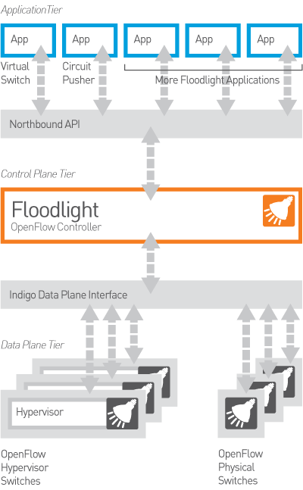

Figure 7 Floodlight SDN architecture [15]

Apart from programmability, Floodlight offers a module loading system, which allows the developer to introduce more functionality to the network and load custom programs. While all this sound complicated, the controller is very easy to set up and has very few dependencies, while it is ready to run fast from day one. One last thing about it is that it is compatible with OpenStack, an array of cloud computing software tools that enable the building and management of cloud platforms.[15][16]

* 1. NOX/POX

NOX is a C++ based platform, which was created to function both as a SDN controller and a component framework for developing software defined network apps. Its original focus was to offer an environment for developing OpenFlow control applications and programs, hence it’s amazing ability to interact with OpenFlow modules, but over the years this was stretched to other protocols. NOX’s core provides a variety of libraries that offer plenty of extra functionality, like methods and APIs for managing switches, along with different components for various network monitoring and management actions.



Figure 8 NOX architecture [5]

NOX is an amazing controller for academic purposes, since it offers a variety of example and prewritten code, ready to be emulated and used in a variety of projects. This does not mean that it is not up for some more serious work – NOX has a huge scalability, being able to handle 100.000 flows per second, which roughly translates to being able to handle a whole university network.

While there was a pre-existing Python interface for NOX, working as a wrapper for its entirety, a newer Python based version was developed, called POX (NOX in Python). With its API, it focuses on high level SDN applications, allowing virtualization and network visualization through graphs. In general, POX offers a variety of advantages over NOX, including easy installation, it is flexible on the environments it can run on (Linux, Windows and Mac OS) and has the same GUI and tools as NOX.

Both platforms use the most current version of OpenFlow.

[5][17][18]

* 1. Ryu

Ryu is a SDN controller written completely in Python. It is component-based, meaning that each function executed by it needs to be launched as a separate part, and completely open source. Ryu supports a variety of protocols, including OpenFlow, Netconf etc., while offering its own APIs for developers to easily create new network applications.

One could say that Ryu is one of the most transparent controllers out there, since it offers a variety of options, when it comes to custom programming on it. Since it offers its own libraries, and everything runs on Python, one can start writing his, or hers, own application by running a 5-lines script offered by the developers. All these make Ryu very “newbie” friendly, and amazing for introducing SDN.



Figure 9 Entirety of Ryu components [5]

Additionally, Ryu also includes functions that use other application, like Snort and topology visualization, which make it possible to extend its usage when it comes to monitoring or security.

Ryu code and files are organized in 6 main folders, making it easy to identify where is what:

* app/ – Includes applications that run over the controller.
* base/ –  Includes the main class for RYU developed applications.
* controller/ –  Includes files dedicated to handling OpenFlow functions, like event generation, flow generation etc.
* lib/ – Includes packet libraries for header parsing.
* ofproto/ – Includes information specifically for OpenFlow and parsers that have to do with it, in order to support multiple versions of it.
* topology/: Includes code implementing topology discovery in OF switches.

All these are included in the /ryu/ folder and shouldn’t be hard to locate.

1. Security in Networks & SDN

In this chapter, we will try to understand further how security in networks theoretically works, how it is implemented and how it generally enforced. By understanding how legacy networks security works, we can then proceed to tackle the matter of security in SDN, on which this thesis is also based. In the following parts, I will analyze the OSI model and how it got turned into a security standard, basic kinds of attack categories and system security methods, eventually ending up to SDN security matters and suggestions.

* 1. Legacy Networks Basics: The OSI model

The OSI model, or Open Systems Interconnection model, is a concept that visualizes the way communication or computing systems communicate with one another, without including each individual system’s components. This way, the model aims to standardize how and where each protocol works, without the need to worry about each system’s gears, since all of them will, eventually, give us the same result.

The model is represented by 7 layers, as seen in Figure 10, each one showing a specific part or function data must go through, to move from one system to another. [22][24]

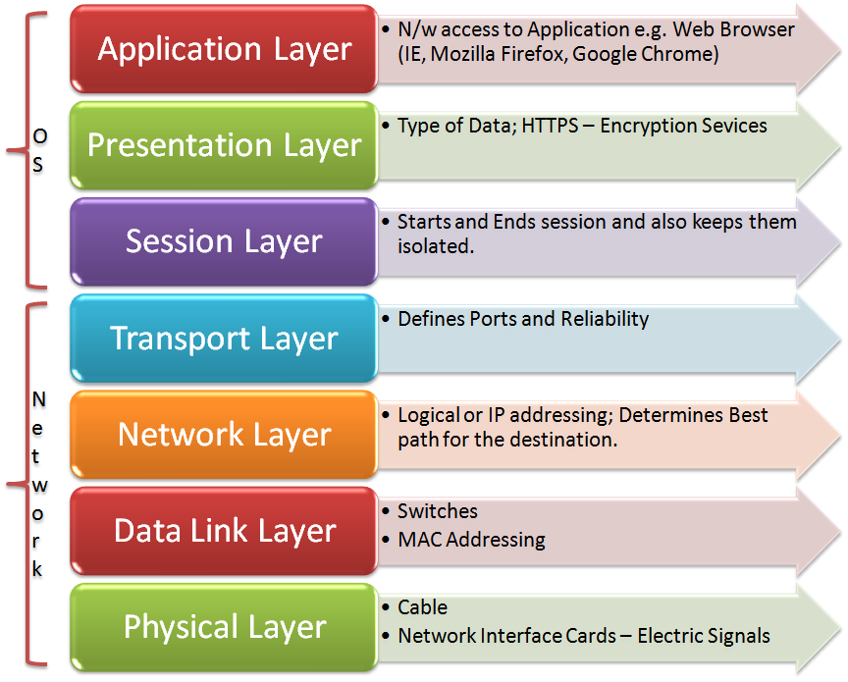

Figure 10 The 7 layers of OSI model [23]

Each layer communicated directly with the one above and below it, providing several functions for the first one while depending on the second. Also, each layer communicates directly with its equivalent in another system. For example, the transport layer (layer 4) of Computer A sends control messages to the transport layer of Computer B, with which it is connected with. Let’s analyze each layer:

* + 1. Physical Layer

This is the first layer of the OSI model, being at the bottom of it. Consisting of cables and connectors, it is responsible for transmitting and receiving bits, defining protocols for data transfer over the network nodes. In a sense, it is the “middle-man” between the network layer (Layer 2) and the physical devices in the network.

* + 1. Data Link Layer

Being in direct communication with the physical layer, the data link layer receives bits from it and converts them into data frames, so they can be passed onto higher layers. In addition, in this layer resides the function of Error Detection and Correction, which is applied to each individual frame in different ways. SDN highly utilized this layer of the OSI model, in order to forward data to specific destinations, through flows. Also, this the layer where physical devices, like switches, reside.

* + 1. Network Layer

In this layer, the data frames are converted into packets, their route is determined in order to be forwarded and updates are sent to the upper levels, regarding the packet’s destination. Also, this is where a logical address (IP) is assigned to every device and is matched with their physical address (MAC). Additional functions in this layer include data congestion and loss solutions.

* + 1. Transport Layer

This layer is responsible for converting all the received packages into segments, providing error checks and flow management for a successful routing. In case there is a delivery error, the request for retransmission happens here. The most usual protocols found in this layer are the connection-oriented TCP (Transmission Control Protocol) and the connectionless UDP (User Datagram Protocol).

* + 1. Session Layer

As the name suggests, this layer is responsible for session management. It manages, begins and ends network sessions between processes of user applications. This also implements that this layer controls who can transmit, at what time and for how long, while it also provides identification, ensures secure connections and synchronizes connections. In case of connection loss, this layer will try to reconnect.

* + 1. Presentation Layer

This is where data formatting happens, converting data and information into formats that the rest of the layers can understand, specifically the Application Layer. Additionally, this layer also encrypts and decrypts data, serializing data and converting protocols.

* + 1. Application Layer

This is the last layer in the OSI model, being at the top of it. In this layer reside the applications with which the user interacts with and with which he/she gains access to different network services. In SDN, this is also where all the applications for network control are, giving the user the ability to control how the network functions.

* 1. Legacy Networks Security: The OSI security architecture

In order to evaluate the security needs in an organization, or any array of systems that belong to a network, the security engineer, who is responsible for this task, needs to assess multiple products and policies, in order to figure out what is best for the system he is managing. This activity requires lots of effort, in order to correctly pin point exactly where each network vulnerability is, and how to tackle it. This is where a security architecture based on OSI comes in. By standardizing and organizing the steps a manager must take, in order to implement security inside a system or a network, the job of protecting an infrastructure has become less research intensive and more transparent. Since the OSI model was implemented as an international standard, most computers and networks have developed their security standards around this architecture. Since SDN functions similarly to legacy networks, when it comes to the OSI layers, one can implement this model on it as well. [21][25]

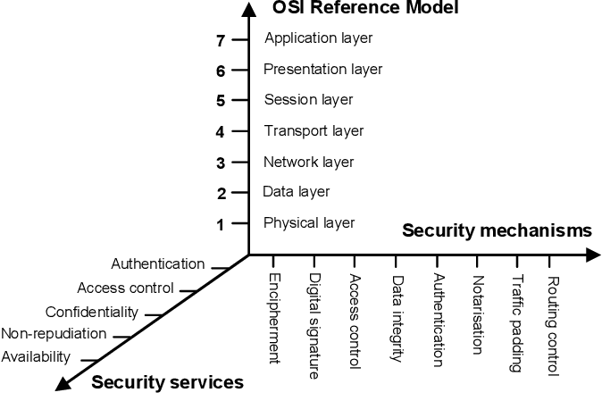

Figure 11 The OSI security architecture [25]

The OSI security architecture has 3 main focuses: 1) Security attacks, which describe any action that breaks the integrity of information and computer systems inside a company, 2) Security Mechanisms, which are hardware or software that aim to protect system infrastructures from security attacks, and 3) Security Services, which are services that implement security mechanisms. A few examples of the last two can be seen in Figure 11 [21] [25]

* 1. Legacy Networks Security: Categories of attacks

[21][26][27] As we know, so far, every system and network can be a victim of some kind of security attack, from an ill-intentioned source. Based on the previous theory, we can categorize each kind of security attack, based on the way it works, into 2 categories: Active Attacks and Passive Attacks.

* + 1. Passive Attacks

Passive attacks are, usually, the first kind of attack a malicious source will use again a system or network. Their goal is not to harm their target but, instead, gather information about it, in order to make active attacks, which Iwe will analyze in the next sub chapter, more successful. This category of attacks includes actions more likely to be described as eavesdropping and monitoring of transmissions, or reconnaissance of system information, such as open ports, active connections etc.

The most usual kinds of passive attacks are port scanning, wiretapping, traffic analysis, idle scanning (method of TCP scanning) and so on.

Because passive attacks do not cause any information or data alternations, they are hard to detect. Usually, the packets that contribute to the attack, and are received by the target, are seen, by the system, as non-suspicious packets, most of the times. Hence, the best way to deal with them is not to detect them, but to hide the information they are after, usually by encryption.

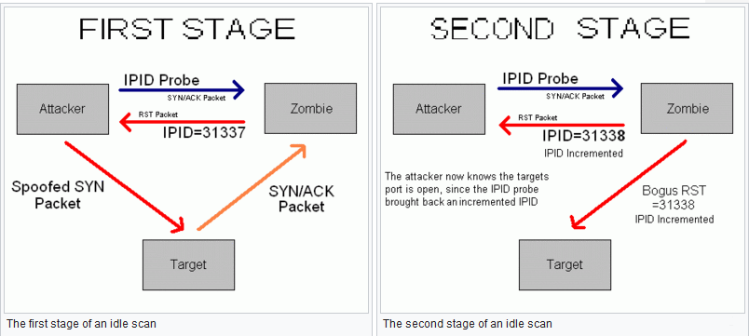

Figure 12 An example of an idle scan, using a “zombie” pc [28]

In my experimentations, the passive attack I will be using is called “port scanning”

Port scanning is a method for an attacker to figure out whether specific ports and services are open on a targeted host. This is achieved by sending “rogue” TCP packets with specific flags to multiple ports, which aim to produce a specific reply when they arrive at the target’s ports. Based on the reply each port will produce, the port scanner can report whether a port is open, filtered or closed. [54]

* + 1. Active Attacks

After analyzing passive attacks, it is time to analyze what often follows them – active attacks. Active attacks, like their name suggests, include action, usually a modification, in specific data paths or systems and hardware. In most cases, this kind of attacks will use information that was gathered during a passive attack, like ID’s and passwords, and use them to, for example, bring a website or a server down, or break into a computer and steal sensitive data. In general, these attacks can be a DoS (Denial of Service) attack, message modifications during a flow, package headers flooding, Phishing, Viruses, Man in the Middle etc.

When it comes to detectability, active attacks can be easily traced and detected, contrary to passive attacks, but are difficult to prevent, since there is such a big variety of them. So, in this case, the target of every security manager is not to prevent them but trace them successfully and recover from them without much damage. Attempts to prevent them can also happen, if the attacks are traced efficiently.

The active attacks that will be used in the experiments in chapter 7 are called “Flooding attacks”

A flooding attack is a type of Denial-of-service (DoS) attack that aims to make an attacked system uncapable of delivering packet services, by flooding it with big amounts of packets and data, making the targeted service ports unable to function, hence denying service to all clients.

The two kinds of flooding attacks I will use are the following:

ICMP Flooding, or ping flooding, which utilizes ICMP packets of big size that are sent at very fast sequences. By sending the target big sized or spoofed ICMP packets at a high sequence, the attacker forces the target’s port to utilize the entirety of its bandwidth to reply to all the received packets, making it unable to service other incoming requests.

On the other hand, a TCP SYN flood works in a similar way, but utilizes a TCP protocol function called “threeway handshake”. By sending multiple TCP packets with a SYN flag at the target, the attacker fakes a handshake initiation and makes him reply to the receiving request. But the handshake is never completed, leaving the targeted port occupied until the request is resolved. By sending more SYN packet to more ports, it can force a server to become completely unavailable.

[55][56]

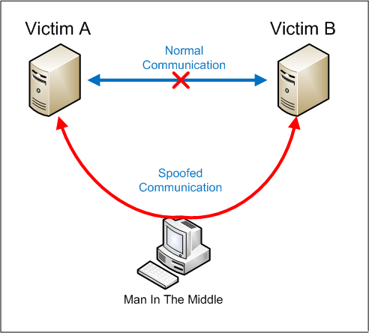

Figure 13 An example of how a "Man in the middle" active attack works

* 1. Legacy Networks Security: Mechanisms and Services

Since the practical part of this thesis will be based on a secure implementation of an SDN infrastructure, it is essential to understand what security services and mechanisms are. In later parts of this chapter, I will showcase Firewalls and IDS further, since these are the security systems I will be using for my examples.

In order to tackle the security attacks mentioned before, specific security mechanisms and services have been developed and categorized. Of course, the thin line that separates those two is not very clear, therefore they can easily cause confusion. Let’s make their definition clearer, before we continue.

According toW3C Web Service Glossary, based on RFC 2828**,** a **security service** is a service providing a specific sort of protection inside a system and implementing security policies. This kind of services are implemented by security mechanisms**.** A good example of a security service is Access control, offered by most servers.

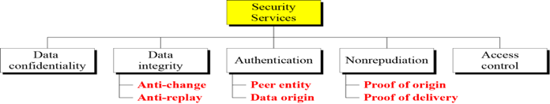

Figure 14 Security Services, according to X.800 [27][32]

On the other hand, **security mechanisms** are the methods through which services can be achieved. They are processes that implement security services inside a system. For example, in order to achieve data integrity inside a server, a security module may encipher its data, or require specific digital signatures. Security mechanisms are usually divided into those which are used in specific OSI layer protocols, like TCP or a protocol in the application layer, and those which do not specialize in any protocol nor service. In Figure 15, we can see a list of those mechanisms, separated accordingly.

Based on the descriptions for each mechanism and security, I will further describe the concepts of Intrusion Detection Systems and Firewalls, which belong in the mechanism categories of Access Control, Data Integrity and Event Detection.[27][31][32][33][34]

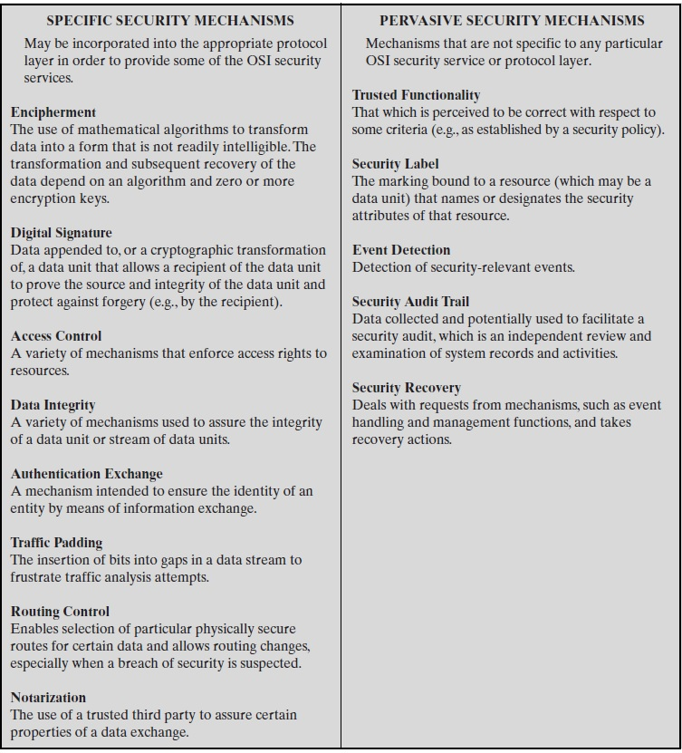

Figure 15 Security mechanisms, according to X.800 [27]

* 1. Legacy Networks Security: Intrusion Detection/Prevention Systems (IPS/IDS)

The first part of the security mechanisms analysis will be an intrusion detection system. In this sub part, I will describe what an IDS is, how they work and how they can be turned into IPS (Intrusion Prevention Systems).

An intrusion detection system, or IDS, is a system that detects intrusions and helps face those attacks, inside a network system. It achieves this by collecting information from the system and analyzing them to find possible threats or attacks. These systems can either be network based or host based, depending on how they work. Network-based IDS are more common and look through incoming network traffic for intrusion elements, while host-based IDS monitor user activity and process activities, on local machines, for intrusion signs. Each one of them has its own strengths and weaknesses.

Every IDS consists of 2 components, in order to work properly:

* Network Node Intrusion Detection System (NNIDS), which analyzes traffic that goes through the network towards a specific host. The difference with NIDS is that traffic is monitored on one host and not on the whole network or subnetwork.
* Host Intrusion Detection System (HIDS): It captures a snapshot of the existing files in the host system and compares it with previous snapshots. If critical files have been changed or are missing, it alerts the system manager.

After this introduction, let’s analyze the capabilities of an IDS. Naturally, an IDS is not the perfect solution to every network security issue. Therefore, some boundaries must be placed, in order to separate what an IDS can and cannot do.

An IDS can:

* Offer better integrity in our infrastructure.
* Recognize and report system or network threats.
* Recognize errors in system configurations.
* Help a security manager into issuing critical security policies.
* Make system security management more transparent, therefore easily possible.

On the other hand, an IDS cannot:

* Make up for a poor authentication and recognition module.
* Analyze attacks without human intervention.
* Work as a “cure” for weak protocol implementations.
* Analyze every possible traffic inside a busy network.
* Deal with packet-level attacks with 100% success.

Why IDS though? That is a very important question someone would ask, since there are so many problems to deal with, and another more solutions for each individual problem.

A computer or network system require confidentiality, data integrity and security. These are the three security services an IDS can offer, and these are the 3 reasons why a security manager should use one, in order to tackle, or discover, attacks and be able to deal with them in the future. [35]

* + 1. IDS approaches

There are two ways to implement the detection of a threat with an IDS, either based on an Anomaly Detection model or based on a Signature Detection model.

**Anomaly Detection** works based on the activity it monitors. If it detects a new kind of activity, or a familiar activity that does not behave as it should be, inside a system, then the IDS alerts the manager. In case the IDS inspects just the packet headers, in incoming traffic, then it is based on a Protocol Anomaly Detection model.

This model of detection usually alerts the user when it detects unusual behavior in a user’s account, unusual access to files and data, high CPU usage, unusual logins, big number of sessions and generally unusual content. Examples on those cases could be big numbers of incoming ICMP packets, or a big increase in port scans.

The pros of this way of detection is that, it can analyze traffic, activity and behavior, inside the system, on the go, can analyze past threats and files differences between “normal” behavior and on-going behavior. The cons of this model is that it is prone to false alarms and can be tricked, if an attack looks like a “normal” behavior inside a system.

**Signature detection**, on the other hand, works by using specified patterns called “signatures”, which are rules inside the IDS. By using those rules, the system can detect whether specific events are malicious or not. An example of such rules could be “More than 1000 SYN packets arrive at port 80”. When this event occurs, the system will alert the manager.

Most signature detection systems are based on a simple pattern matching algorithm, which, in most cases, just looks for specific sub-strings inside a series of data that are transferred through the network. When those sub-strings are found, then the packets are considered malicious. Signature detection systems function in Layer 7 of the OSI model.

The pros of those systems are that, they can also detect traffic and events on the go, while they work best with attacks that have been detected and logged in the past (since a human will have created a set of rules to deal with them). The downside is that, they must be updated constantly, they require huge rule sets in order to tackle most attacks and threats out there and need powerful computer systems to function properly.

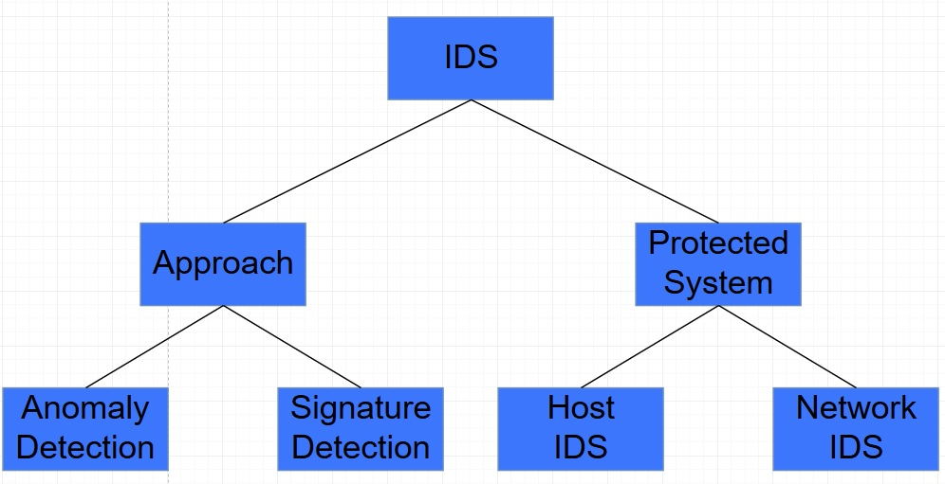

Figure 16 IDS set-up structure

After the IDS model has been chosen, and the system is protected, there are 2 ways to implement the IDS inside the said system, either as a Host Intrusion Detection or as a Network Intrusion Detection system.

Like the name suggests, Host IDS looks for intrusions on a local host system. It searches for unusual behavior that has been confirmed by the local host, like logins, unusual file access or unauthorized grant of privileges etc.

Network IDS, on the contrary, monitors parts of a network. It consists of two components: a sensor and a management center. The management center receives data and alarms from the sensors and passes them to the administrator. Sensors are usually systems with the sole purpose of monitoring the network. They have a web interface in active mode, so they can receive and monitor every kind of traffic in the network, not just traffic meant for their IP address. If they detect something, they send an alarm to the management station.

In the next section, we see more on Firewalls, and how they can be used as an effective IPS solution.

* + 1. IDS vs IPS: What is the difference?

After analyzing IDS so much, I should have given you a clear view of how it works and what it does. But the big question arises: what is its difference from an IPS? The answer can simply be given by their names. IPS stands for Intrusion Prevention System, while IDS stand for Intrusion Detection System. The first one functions like an invisible “wall”, residing inside the network and using policies, and rules, to detect and stop specific traffic inside the network, if it catches anything suspicious. The second one, on the other hand, simply monitors system behavior or traffic going through a host or a network, looking for suspicious events and informing the administrator if any has been detected, but does not take down any traffic nor packages.

In the next section, I will describe the Firewall in more detail, and how it can be combined with an IPS to be used as a solid security mechanism. [29]

* 1. Legacy Networks Security: Firewall

Another addition to the security implementation is a firewall. A firewall can be a hardware system, software system or a combination of both that prevents access to an internal network, usually by stopping incoming traffic. Its main purpose is to separate parts of a network from each other or separate an internal network from the Internet. As seen in Figure 17, it’s a good way to separate the “good guys” from the “bad guys”

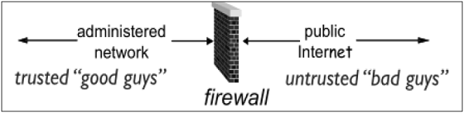

Figure 17 Comical network partitioning by a firewall [29]

A firewall is an important element for any network, which offers security for anything that stands behind it (behind the point in the network it was set up on) and preventing any unauthorized access to that network part. This means that, it could prevent security breaches, attacks and any other danger that lurks in the World Wide Web.

Firewall can be categorized into 3 categories, 1) Packet filter, 2) Application level gateway and 3) circuit level gateway. Even though these categories do exist, firewalls can’t solely fall directly into one of those, since a combination of methods is used in modern firewall solutions.

**Packet filtering firewalls** do exactly what their name suggests: they filter incoming or out-coming packets and allow or block them, based on several rules set by the administrator. They work by comparing packet headers and IP addresses on the traffic they filter against tables, called Access Control Lists (ACL), where the filter rules are. If a packet’s content matches some rule’s criteria, then the packet can go through or it gets blocked, depending on the rule. Rules are consisted of two parts, the selection criteria which is used for matching packets with the rule, and the action field, that indicates what actions are to be taken if a packet matches with the rule.

Now, if we want a more advanced kind of packet filtering, that checks packets which belong to a connection rather than all the packets that go through the filter, we need to implement a stateful firewall. Stateful firewalls, unlike stateless ones which filter every packet that goes through them, monitor connections on the TCP/IP level. They start using their ACL only when a new connection is established, and the packets that are being compared to those tables belong to one of the initiated connections the firewall monitors. Additionally, since this type of firewall goes more in-depth on a connection, it can also take over functions like connection setup or connection ending.

**Application Gateways** are firewalls that filter traffic on the application layer of the OSI model. They receive incoming and outgoing traffic on proxy servers, analyze them and then copy them and forward them to their destination. This way, the application never comes to direct contact with an untrusted source. These proxies are also good for blocking specific services inside a network. For example, through a proxy on a central server, the administrator can configure the proxy to deny requests like FTP put, hence preventing data modifications. Another aspect of those proxies is that they are application specific, meaning that they can only be configured to be used for specific services. This means that if a network depends solely on this kind of firewall, the only services that can be used are those the firewall proxies are configured for, since any other kind of traffic will be rejected.

Last, we have **Circuit Level Gateway,** which combines both functions of the firewall types I mention before and run on the transport layer of the OSI model. This means that, it can work as a proxy for any kind of application and service. This firewall utilizes proxy servers called SOCKS, based on RFC 1928, which authenticate any user that wants access to the other side of the firewall. The authentication has the following steps: First, user sends a connection request for the IP he wants to connect with to the SOCKS server. Then, the SOCKS server checks if the user is trusted, based on specific filters and accepts the request, opening a connection between him and his destination, while monitoring their connection. Finally, SOCKS let the user know that a connection has been established and begins to transmit data. [2**1**][29]

* 1. Security in SDN

After analyzing and figuring out how security in legacy networks works, it’s time we see how it is implemented in a software defined network. This will also be my main research point in the next chapters, where I will be testing legacy network tools and methods on an SDN infrastructure.

As we know, so far, SDN is a network infrastructure concept, where the control over the network nodes is centralized in one place, called a controller. Hence, new security concepts arise, since now security must also include the controller, where all the info about the network exist, except from the network nodes, but also all the data paths and flows that make up the “life essence” of the network operations. Of course, this is not necessarily a bad thing, since centralized control means that we don’t have to worry about a malicious user taking over the control of a network node somewhere on the network, if the control is centralized and well protected, in one place. And, flows and devices can also be protected with traditional means, as we will see in this chapter. In figure 18, we can see several threats that could occur inside an SDN infrastructure. Those threats are numbered as 1) forged or fake traffic flows, 2) attacks and vulnerabilities in switches, 3) control plane attacks, 4) controller attacks and vulnerabilities, 5) untrusted communication between the controller and applications, 6) attacks and vulnerabilities on the admin station, and 7) untrusted sources of forensics

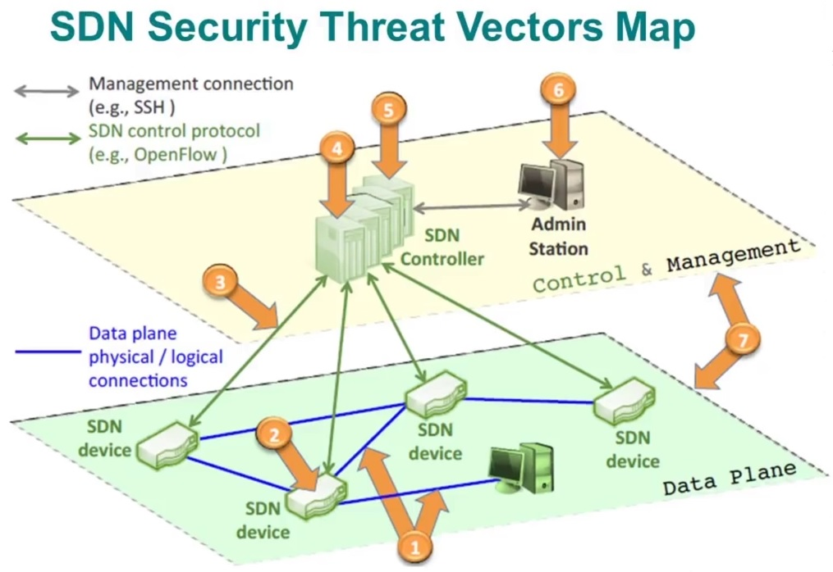

Figure 18 SDN Security Vector Map [37]

Based on this, and keeping in mind the different software and hardware parts that constitute an SDN infrastructure, we can separate the security in said infrastructure into 5 parts: application plane security, control plane security, data plane security and security in the northbound and southbound interfaces.[36][37]

* + 1. Application Plane Security

The application plane is the highest layer in an SDN infrastructure, and it includes all the applications and software that come to direct communication with the controller, through the northbound interface. This software is responsible for controlling the data flowing through the network, by managing the controller.

In this layer, we can implement security mechanisms both for other layers and the application layer itself. While OpenFlow is friendly towards integrating security applications and policies, the standard usage of those is lacking. One of the biggest vulnerabilities an administrator will meet in this layer has to do with flow integrity. Through unauthorized access, malicious applications could manipulate rules and alternate how the network functions or allow malicious traffic in without any notice. In order to deal with these issues, there have been some suggestions on this matter.

For starters, in order to ensure the network is working as it should, an administrator needs to be able to run forensics and view statistics. **CloudWatcher** can help with that by offering traffic analysis, packet filtering and pre-installed policy implementation. Finally, it can forward suspicious packets to specific devices for further inspection.

Another important aspect an SDN infrastructure must have is a good firewall. **FLOWGUARD** is an OpenFlow based firewall, for inspecting and detecting policy flaws and issues. When an issue occurs, this firewall does not simply block traffic but, instead, analyzes the issue and acts based on it. At the same time, it can monitor flows one by one, in real time, while logging activity across the network.

Of course, all those offer protection in case someone breaks in or tries to do so, but they do not actively stop an attacker from gaining access to the system through access control. This is where access control solutions come in. **FortNOX** is a role-based authentication and security mechanism, implemented directly inside the control plane. It offers security and policy implementation and enforcement, while it detects flow rules collisions, through constant flow table analysis. When a collision between rules occurs, FortNOX checks the flow rules and applies the one with the highest priority.

Finally, we have **FRESCO,** a development platform that was created in order to simplify and enhance the implementation of security applications in OpenFlow. By using high-level security policies and functions, and having access to whatever happens inside the network, FRESCO can detect threats and attacks, by comparing network statuses, and create a database of “network states information”. In case of an attack, this platform offers three actions, mirror, redirect or quarantine. In the first case, the suspicious traffic is copied from the switch that received and is sent to the pre-set security system of further analysis. In the second case, the suspicious traffic is sent directly to its destination. Finally, in the last case, traffic is forwarded strictly to specific hosts, that can keep the problematic host in quarantine. This way, any threat is minimized strictly yet efficiently.

We should keep in mind that all those suggested ideas are OpenFlow-based, hence work directly with OpenFlow. In later chapters, through personal experimentations, we will see Application Layer solutions, targeted mainly for legacy networks, which can offer basic IDS and IPS functions to enhance network security inside an SDN infrastructure. [36]

* + 1. Control Plane Security

The whole idea of SDN is to centralize control into a single point, in order to simplify management and security, while maintaining performance. This single point of control is the controller, which technically is the control layer. While it is convenient to control a network through a single point, it is also one of the biggest vulnerabilities this infrastructure has. While the network nodes can be multiple and spread out, If the control of the network nodes is in one place, this means that a possible attacker only needs to take over one server, in order to take out the whole infrastructure, ignoring all the other nodes. Therefore, the security of the controller is of critical importance, in order to avoid unwanted downtime and issues around the network, but also to avoid unwanted control violations.

Because of the centralized control, we realize that the most common and dangerous type of attack on an SDN infrastructure is a DoS and DDoS (Denial of Service and Distributed Denial of Service, respectively) attack, hence I will focus on methods and ideas based around these.

These attacks are very hard to deal with, yet very simple to launch, mostly because of the traffic they use to be achieved. In many cases, the attacker will generate packets of various kinds, from ICMP to TCP, in order to flood our server. Those packets, if sent correctly, would never look suspicious to the human eye nor to most traffic analyzers. Therefore, we need to look for more specific solutions to the matter.

One theoretical idea, based on beginner’s knowledge about SDN, could be the use of more than one controller inside a network. In this case, we don’t need to focus on avoiding an attack but, instead, immediately recover from one, by using backup controllers. As soon as one controller is down, and does not respond to any requests, the second would take over with the exact same flow entries as the first one. This can be achieved with more than one backup controllers and requires a mechanism that keeps all the extra controller synchronized with the main controller so, in case one of the fails, another can take its place without issues.

Another, more in-depth idea, is analyzed briefly in Talal Alharbi’s work, is the introduction of DDoS detection, where specific mechanisms use flow statistics from the network switches, in order to protect the system from DDoS and DoS attacks. Or implementing mechanisms in the flow functions themselves, to extract statistics in set times, alarming the user in case of suspicious events.

Of course, there is the idea of implementing an IDS-like solution on this level, by making the system work at lower levels, checking flows directly and alerting the user if abnormal behavior occurs or if specific triggers are activated, based on rules and detection algorithms. After the suspicious events have been detected, automated countermeasures could be activated, based on the type of alert that has been triggered.

Last, another theoretical and personal idea could be the implementation of an authentication system that the user must go through if he wants to access specific parts of the network, like switches that are the closest to the controller. This could potentially create a sort of firewall around the controller, which prevents unauthorized access to any malicious users. Of course, this requires work to achieve, since traffic must go through several network nodes, including those close to the controller, in order for solid connections to be established. Therefore, it is a theoretical example that can hardly be achieved. [36]

* + 1. Data Plane Security

In SDN, the data is forwarded around with the use of SDN switches. Those switches function is to simply forward packets around the network, based on the “instructions” they have received from the controller, since they do not have any access to the control plane. These instructions come in the form of rules, which are found in flow tables. In order to increase the forward speed, SDN switches save those flow tables in what is called Ternary Content Addressable Memory or TCAM. This type of memory can be very expensive; hence each switch has a very limited amount of it. To makes things worse, switches often have to store uncategorized traffic, which does not apply to any flow in their tables, taking up more space in the TCAM until the controller has categorized it correctly and they can forward it to its destination. As you have realized, the size of this memory is the biggest vulnerability in the data plane, since an attacker could easily take out multiple of those switches with a DoS attack on them, by flooding them with several unknown packets and uncategorized flows, which will have to be saved in the buffer of the switch, for categorization by the controller. This way, the TCAM in each switch that is affected will be filled, making it unable to perform its functions properly or shut down.   
There have been a few ideas to tackle the main problem inside the data plane, but all of them require major changes in protocols like OpenFlow, and in the idea of how SDN functions. Let’s see a few of those.

The first idea focuses on tweaking the OpenFlow protocol, using DevoFlow, a modification to OpenFlow for better flow management that includes less interaction between the controller and the switches. In this modification, switches use what is called “microflow rules” instead of normal flow rules, which match packet headers in incoming packets and configure regular flow rules accordingly, without the need of waiting for the controller to create new flows for uncategorized packets. The controller’s work, in this idea, is to implement the global flow rules and policies on the network. However, through this implementation, the idea of centralized control becomes a bit hybrid, since switches can make their own packet forwarding, like in legacy networks.

A different approach is the usage of several switches, with extended TCAM and traffic processing potential. Through DIFANE, a modification of OpenFlow, like DevoFlow, switches can forward buffered traffic that cannot be matches with a flow rule to a special switch inside the network, where it will be stored and handled locally. This way, the switches do not have to wait for controller “instructions”, since everything happens locally. Except from modifying existing rules, those “special” switches also can create new rules, but also to learn and detect topology changes, making the need for a controller minimal. Of course, this goes way off the idea of SDN, which does not implement distributed control along the network.

Lastly, we have AVANT-GUARD, an extension for OpenFlow, which gives SDN switches the ability to run forensic analysis on traffic and inspect TCP session requests, without the need to contact the controller. Of course, this tool’s focus is TCP attacks, but it adds a dynamic security ability to our network. In general, such extensions are the least intrusive ideas, when it comes to SDN ideology, and could make it easier for administrators to detect possible attacks, but they do not completely erase existing vulnerabilities, they just patch them. [36]

* + 1. Northbound and Southbound Interface Security

In this last part of security in SDN, I will analyze the security in the connecting interfaces between each major plane, the Northbound and Southbound interfaces. Both planes have similar vulnerabilities, therefore will be described together.

As we know, for the Application and Control plane to communicate, there must be a connection between those two through the Northbound Interface. Through this Interface, an application in the Application Plane can directly communicate with the controller in the Control Plane, sending requests for network statistics and other information, but also commands to add or remove flow rules. Same goes for the communication between the Control Plane and the Data Plane, with the Southbound Interface. In this case, the controller can communicate with the network nodes and switches, in order to retrieve network statistics or events, and update the flow tables in each switch. By locating the data flow between the two communicating layers, we can find and tackle any vulnerabilities that could possibly exist. Usually, those issues have to do with attacks that target messages, and DoS attacks.

For the **Northbound Interface**, possible threats could target the API itself or use the API in order to target other parts of the network. Insecurities in the Northbound interface can happen in several ways. Malicious situations can occur from the Application Plane, through the Northbound Interface, but those were described in previous parts. In the APIs themselves, it is very easy for someone with malicious intentions to spoof messages and even alternate them to his/her likings, in order to cause problems, if proper access controls mechanisms have not been applied.

In order to tackle such threats, access control must be enforced, in order to restrain unauthorized applications from accessing the Control Plane through the Northbound interface, to avoid both Man-in-the-middle attacks and unauthorized access to data and flow control. Also, cryptographic protocols should be enforced, to encipher information that moves between the two said planes, so in case of an eavesdropping attack, the attacker will not be able to make anything out of the information.

For the **Southbound Interface**, things are similar. Of course, in this case, all connections between the controller and the switches is encrypted, using the Transport Layer Security (TSL) protocol, to prevent attackers to eavesdrop or alter information passing through the network or take over the controller. Another issue this part of the network has is vulnerability to TCP attacks. Since it is possible to exploit gaps in the TSL protocol, attackers could flood the network with TCP packets or perform DoS attacks to both the controller and the switches.

Even though those issues are well known, measures to tackle them are completely optional to manufacturers, therefore some select to ignore them. [36][38]

1. Project Idea and Execution

Since one of the issues in SDN is the security of the infrastructure, I developed a few practical examples to tackle those problems, using legacy network tools, researching how they work on SDN and what results they offer. In this part of this paper I will present my project idea and how that was carried out. In the following texts, I will discuss the concept of my ideas, to showcase security in an SDN infrastructure, how they were implemented and how everything was set up.

A quick disclaimer: all the tools I used were open-source and available to anyone, including the research community, with the exception of the python script, which I wrote myself.

* 1. Project Idea

In order to learn more about how SDN works and how someone that has the administrative role over it can make it more secure, I came up with the idea to set up a virtual SDN infrastructure and implement security solutions on it, to see how it will behave while noting statistics about traffic and packet flow. Since, the virtualization tool I used does not come with any SDN-specific security tools or software,

I integrated a legacy security function into my infrastructure implementation. Legacy networks are yet to be outdated, offering a huge variety of legacy security tools one could use. SDN works very similarly to a regular network, when it comes to packet traffic and protocols, therefore it should, and is, possible to use such tools on an SDN infrastructure.

Therefore, the whole project started resolving around this, testing the efficient integration of legacy network security software into our functions, to make SDN more secure and attack-proof.

* 1. Tools

For this project to work, I used the following tools, for the following purposes. First, I had to run my virtual infrastructure somehow. I knew that Mininet is an amazing way to virtually emulate an SDN infrastructure, but it was very limited when it came to graphical interface (which was non-existent), multitasking and combining other tools with it. After some research, I stumbled upon SDN Hub VM, a 64-bit Ubuntu 14.04 image (3GB) that has several SDN software and tools pre-installed, including numerous open source controllers and Mininet, which was perfect for what I needed. In order to run this image, I used VMware, a hypervisor that allows the setup of virtual machines. As my controller, I used a remote controller called Ryu, which is a modular controller offering easy customization and ease of use. After setting up those, I started using Mininet, in combination with Snort for IDS functions, before I started using the default Ubuntu firewall for IPS functions. In the end, I combined those two, in order to set up a full IPS solution. Now, let’s see the tools I used in more details.

* + 1. VMware Workstation



Figure 19 VMware Logo [39]

VMware Workstation is a free, open-source type-2 hypervisor that allows the setup of virtual machines (VMs), which are emulations of a computer system, on a single host without the need of extra hardware components. Through this software, a user can run multiple operating system images like they are separate computer systems and have them behave accordingly. Also, through different setup options, the user can select to bridge existing hardware with the virtual machines, while network options are also available that can allow the user to bridge the VM’s network with its host computer’s or be a separate entity. VMware can run operating systems like Microsoft Windows, Linux, BSD and MS-DOS, making it a very versatile tool for developers and testers. [39]

The reason I chose VMware Workstation was because I have previously worked on it, on other projects, and has proven to be a reliable tool.

There is a Pro version of the Workstation, which I will be using. But, using the free version works perfectly fine, as well.

The same results can also be achieved using other hypervisors, like Oracle’s VirtualBox, which has similar settings as VMware Workstation.

* + 1. SDN Hub VM with Mininet

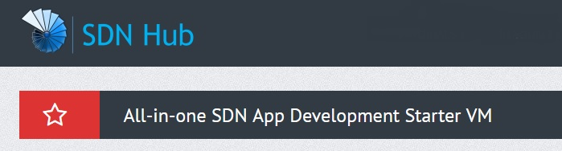

Figure 20 SDN Hub Logo [40]

SDN Hub is an association that promotes SDN through the gathering of many individuals that are interested in SDN. It is known for building SDN applications, informing the community about SDN, throwing and promoting events and testing SDN solutions. In order to help individuals get into SDN more easily, they have made pre-built VM, based on Ubuntu 14.04, which has multiple software and tools for SDN development. This image includes several SDN Controllers, like OpenDaylight, ONOS, RYU, Floodlight, POX and Trema, pre-written code for simple network functions, Openflow supported Open vSwitch 2.3.0 and LINC switch, Mininet, Pyretic SDN Python programming language, Wireshark 1.12.1 and JDK 1.8, Eclipse Luna and Maven 3.3.3 [40]

* + 1. Snort



Figure 21 Snort IDS/IPS Logo

Snort is an open-source network IDS and IPS, made by Martin Roesch. It is used for real time traffic analysis, packet logging and intrusion detection. Snort is very specific, therefore it functions in 3 different main modes, for more specific results. There is the sniffer mode, which read network packets and shows them on the console, packet logger mode, in which he saves incoming and out-coming packets in a log, and finally there’s the intrusion detection mode, in which he read network traffic and compares it against a set of predefined rules, in order to detect unwanted packets. More specifically, snort utilizes the libpcap or winpcap libraries, depending on the operating system it is run on, which use tcpdump for packet sniffing. In general, Snort produces various alerts based on rules that are implemented by a configuration file and are written in a versatile language, which makes them easy to write. Snort will be analyzed further in 6.3 part of this chapter. [41]

* + 1. Firewall (iptables)

All my operations were executed on Linux OS, therefore the Linux kernel firewall was used. This firewall provides a program called “iptables”, which allows the root user of the system to implement firewall rules, stored in tables, which apply to specified packets in different ways and points inside the network, all according to the administrator. All rules compare themselves with a packet based on the origin and/or destination of the packet, at which point inside the network they were applied and on which table they belong to. There are four available tables, in order to categorize rules accordingly: raw, nat, filter and mangle. If a user does not specify one, the rule is applied on the filter table. When a packet goes through the system, it is compared with every existing rule. If a packet doesn’t match one rule, it is compared with the next one. Now, if it does match with a rule, the packet will either be a subject of the rule’s action and will either continue along the rule chain or it will be stopped by the action. Actions can happen on every layer of the OSI model and are implemented by the target/verdict extensions of the rules. The usual way to tweak iptables rules is with shell commands or third party software, which usually make use of pre-written shell scripts or program generated scripts based on rule templates. Usually, the second option can be limited and cannot apply in all circumstances, therefore the use of custom rules made by the admin is advised. I will further analyze the syntax and function of rules in the execution part of this chapter. [42]

* + 1. Python SnortIPS script

After colliding onto issues with implementing the Snort IPS functions in my SDN infrastructure, on Mininet, I figured it would be a good idea to create my own IPS. By using the Python scripting language, and a module called “Pexcpect”, I was able to combine the Snort IDS alerts output with the iptables, from the Linux firewall, and implement my own advanced IPS solution that can make the procedure of viewing alerts and taking actions, based on them, much easier and even automating it. The way it works is the following: by starting Snort through the Python script, and reading any incoming alerts, firewall rules can be applies with an array of “if…else” cases. At the same time, the administrator is able to choose which interface to monitor or to insert his own rules. The whole thing works amazingly with Mininet, and new cases can be easily implemented with a few code tweaks, as we will see in the next part of this chapter.

* 1. Execution

In the last part of chapter 6, I have included a small guide on how to install and set-up all the applications necessary for my project, from the hypervisor I used, to my python script, with the exception of some CLI software, like nmap, which I do not mention since their installation consists of 1 command, The final execution is straight forward, but requires some time and patience to get it done correctly.

* + 1. Part one: Installing VMware Workstation and SDN Hub VM

We want to install VMware Workstation and import the SDN Hub VM on it. Let’s follow the steps for the Workstation:

1. Visit the VMware [website](https://www.vmware.com/products/workstation-player/workstation-player-evaluation.html) and download the Workstation Player. There is the option to download the Pro version, but you will have to pay for it, after the free trial.
2. Download the program and run it. I worked on Windows, therefore chose to download the windows version.
3. Run the executable you just downloaded and follow all the steps necessary. If you have downloaded the Pro version, you might need to enter a product key or choose the free trial time.

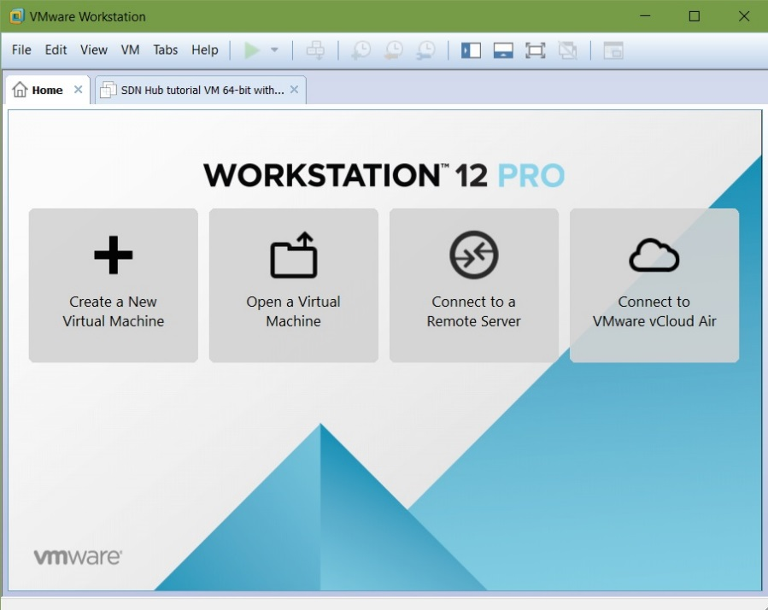

Figure 22 VMware Workstation Home Screen

After the installation is complete, no further settings are necessary. You should have the application installed and ready to run. Through the Home screen, you can open existing VMs, create new ones based on .iso files you have on your computer, or connect to remote servers and clouds.

Now, let’s see how to properly install and set up the SDN Hub VM:

1. Go to the SDN Hub [website](http://sdnhub.org/tutorials/sdn-tutorial-vm/) and download the OVA file of their VM. I chose the 64-bit one.
2. After downloading the OVA file, locate it and run it. It should automatically prompt you to open it with VMware station. Then, VMware Workstation should ask you to import the VM, giving you the option to change its name and file location.
3. In case step 2 does not work, do not press “Retry”. Instead, export the content of the OVA file and run the VMware Workstation application. There, press “Open a Virtual Machine” and choose the .vmdk file, that was exported from the OVA file.
4. The VM should now be shown in the available VMs, on the sidebar. You can select it, by clicking on its name, and see its given attributes.
5. You can change the attributes of your VM by clicking the “Edit virtual machine settings options”. All settings can be changed based on your tastes but, keep in mind that the recommended allocated memory and processors are 2GB and 2 cores, respectively.
6. After you have selected the VM, launch it by clicking on the “Power on this virtual machine” button, or the green “Play” button on the top bar. It should take a bit to start so, be patient. The username and password are both “ubuntu”, in case you are prompted to insert them.
7. After logging in, you can start by updating and upgrading your machine. Launch the Terminal Emulator and type the following commands:

- sudo apt-get update

- sudo apt-get upgrade -y

1. After this is done, you are ready to explore your new VM.
   * 1. Part two: Downloading and Setting up Snort

Even though the SDN Hub VM has a huge variety of tools, it does not include the IDS/IPS Snort, which I will be utilizing in this project. Let’s see how it can be properly installed, in order to function as I want it. Keep in mind that for a full scale usage of the IDS/IPS can be very resource intensive, therefore some minimum specifications are required.

In my project this is not an issue, since the virtual network is small, but in a bigger networks, where the administrator needs to monitor multiple interfaces, the recommended specifications are Ubuntu 16.04+, at least 4GB of Ram, for multiple Snort instances, and 1TB of storage, for logs.

In the following steps, I will describe, step by step, the installation of Snort from source.

1. First, we need to install the necessary dependencies, for Snort to work properly. Using the following command, I will install this list of dependencies:

- sudo apt install -y gcc libpcre3-dev zlib1g-dev libluajit-5.1-dev libpcap-dev openssl libssl-dev libnghttp2-dev libdumbnet-dev bison flex libdnet

**gcc**: GNU C/C++ compiler

**libpcre3-dev**: PCRE (Perl compatible regular expressions) library

**zlib1g-dev**: zlib library for preprocessor function

**libluajit-5.1-dev**: compiler for LuaJIT

**libpcap-dev**: packet capture library

**openssl**: software library for secure communications over the network

**libssl-dev**: SSL toolkit

**libnghttp2-dev**: http/2 implementation library

**libdumbnet-dev**: dumb networking library dev files

**bison**: GNU parser generator

**flex**: Fast Lexical Analyzer

**libdnet**: networking library

1. Create a download file and cd into it.

- mkdir ~/snort_src && cd ~/snort_src

1. Download the Data Acquisition Library (DAQ), necessary for communication between Snort and the packet capture libraries. The “x.x.x” represents the version of DAQ we want to download (ex. 2.0.6). Make sure you download the latest version, by replacing the “x.x.x”.

- wget https://www.snort.org/downloads/snort/daq-x.x.x.tar.gz

1. After the download is done, extract the souce code and go to the new directory, where you should run the configuration script, compile the program and then install it.

- tar -xvzf daq-x.x.x.tar.gz

- cd daq-x.x.x

- ./configure && make && sudo make install

1. Now, got to back to the snort folder you created and download Snort. The “x.x.x” represents the software version. Change it to the latest one.

- wget https://www.snort.org/downloads/snort/snort-x.x.x.tar.gz

1. Once the download is complete, extract the source code, go to the new folder, configure the code with sourcefire enabled, compile it and install it.

- tar -xvzf snort-x.x.x.tar.gz

- cd snort-x.x.x

- ./configure --enable-sourcefire && make && sudo make install

1. After the all these are done, I need to configure Snort for our system. Start by updating the shared libraries.

- sudo ldconfig

1. As good practice, create a link between the Snort installation path and /usr/sbin/snort.

- sudo ln -s /usr/local/bin/snort /usr/sbin/snort

1. In order to run Snort without root, I should create a new unprivileged user and user group for it to run under.

- sudo groupadd snort

- sudo useradd snort -r -s /sbin/nologin -c SNORT_IDS -g snort

1. Create a folder structure for further Snort configurations.

- sudo mkdir -p /etc/snort/rules

- sudo mkdir /var/log/snort

- sudo mkdir /usr/local/lib/snort_dynamicrules

1. Set the necessary permissions for the new directories.

- sudo chmod -R 5775 /etc/snort

- sudo chmod -R 5775 /var/log/snort

- sudo chmod -R 5775 /usr/local/lib/snort_dynamicrules

- sudo chown -R snort:snort /etc/snort

- sudo chown -R snort:snort /var/log/snort

- sudo chown -R snort:snort /usr/local/lib/snort_dynamicrules

1. Create the necessary files for the whitelist, blacklist and the local rules.

- sudo touch /etc/snort/rules/white_list.rules

- sudo touch /etc/snort/rules/black_list.rules

- sudo touch /etc/snort/rules/local.rules

1. Copy the configuration files to the main Snort folder.

- sudo cp ~/snort_src/snort-2.9.12/etc/*.conf* /etc/snort

- sudo cp ~/snort_src/snort-2.9.12/etc/*.map /etc/snort

After following those steps, Snort configuration and installation should be complete. In the next part of this chapter, I will configure Snort’s rules properly, in order to detect possible threats. These rules are categorized into 3 kinds: community rules, registered rules and subscriber rules. We will also see how to change between modes, to utilize its IPS functions.

* + 1. Part three: Setting up Snort rules and IPS mode

With Snort’s configuration out of the way, it is time to work on another very important part of it: its rules and modes. Like you have realized, after all these descriptions and information, Snort is a signature-based IDS/IPS, therefore its functionality is based on preset rulesets that generate alerts, in case a filtered packet meets their criteria. Also, Snort can function in different modes, depending on what the user wants it to do. We have the sniffer, packet logger and intrusion detection mode, all with their own functionalities. Let’s see how to configure Snorts rules to work properly, analyze their structure, and syntax, and see how they can be used in different modes.

## Downloading and implementing Rules

There are three options, when it comes to obtaining rules, for free, for Snort: downloading community rules, downloading registered user rules or inserting your own rules.

**Community rules** are free and available without any registration, but can be limited. They can be downloaded and copied in the Snort file using the following commands on the cli:

- wget https://www.snort.org/rules/community -O ~/community.tar.gz

- sudo tar -xvf ~/community.tar.gz -C ~/

- sudo cp ~/community-rules/* /etc/snort/rules

**Registered user rules** can be downloaded using a special code called “oink code”. That code is obtained when the user registers on the official Snort website, and offers access to a bigger variety of rulesets, which offer a wider detection spectrum. After registering on the website, you can use the following command to download and extract the rules on your Snort file. Replace the “-oinkcode-“on the command with your actual Oink Code.

- wget https://www.snort.org/rules/snortrules-snapshot-29120.tar.gz?oinkcode=-oinkcode- -O ~/registered.tar.gz

- sudo tar -xvf ~/registered.tar.gz -C /etc/snort

**Personal rules** can be implemented by creating a .rules file inside the Snort rules folder and use their own rules. There, the user can insert all the rules he/she desires, for testing or actual use. This is a good way to separate your personal rules from downloaded ones, try out the Snort rule language or test your rule configuration.

They can be found in the “/etc/snort/rules/” path.

After downloading and inserting all the rules we desire, we need to configure Snort further, so it can utilize them. In order to do that, I need to tweak the Snort configuration file, using a text editor, with the following command. I’ll be using Leafpad for this, but any text editor will work fine.

- sudo nano /etc/snort/snort.conf

Optionally, in the configuration file, we can start by setting up some variables. We can tweak the HOME_NET variable, which is used to implement the IP address of the computer we want to protect. Similarly, we can set a variable for external network addresses, using the EXTERNAL_NET variable. If you don’t want to bother yourself with these, leave them as they are. They can be found in the following sections in the file:

# Setup the network addresses you are protecting

ipvar HOME_NET server_public_ip/32

# Set up the external network addresses. Leave as "any" in most situations

ipvar EXTERNAL_NET !$HOME_NET

After those configurations, we should find the section where the rules file path was set, as well as the whitelist/blacklist paths, and set the path for our logs to be saved. These can be found in the following sections:

# Path to your rules files (this can be a relative path)

var RULE_PATH /etc/snort/rules

var SO_RULE_PATH /etc/snort/so_rules

var PREPROC_RULE_PATH /etc/snort/preproc_rules

# Set the absolute path appropriately

var WHITE_LIST_PATH /etc/snort/rules

var BLACK_LIST_PATH /etc/snort/rules

# unified2

# Recommended for most installs

output unified2: filename snort.log, limit 128

If they look like that, leave them as they are.

Finally, I have to instruct Snort to recognize our new rule sets. To do this, I have to find the part where all the included rule set are. This should be towards the button of the file. There, add the following lines, replacing the .rules file with any rule file you want Snort to use.

include $RULE_PATH/community.rules

include $RULE_PATH/local.rules

After all these configurations, we should be ready to validate our configurations. To do this, simply run the following command, where the –T parameter starts Snort in test mode.

- sudo snort -T -c /etc/snort/snort.conf

The output should declare info about various module versions, as well as preprocessor versions, and end with “Snort successfully validated the configuration!

Snort exiting”

Now, we are ready to learn how to make some rules to implement, as well as test them out.

## Rules Analysis

[46]Like I mentioned before, rules are used by Snort to generate alerts, when packets that meet the rule criteria are filtered through it. A rule consists of two parts, the **Rule Header,** which implements functions like alerts, log, pass, activate and CIDR (Classless inter-domain routing), and **Rule Options**, which confirms the alert messages according to the rules.

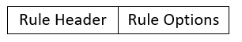

Figure 23 Rules structure

Snort rules that are implemented inside our system should be compliant enough to act immediately, and take all the necessary corrective measures. According to the actions they take, rules can be separated into 3 categories: Alert Rules, which produce an alert, Log Rules, which log the packet after the production of an alert, and Pass Rules, which ignore and destroy the packet.

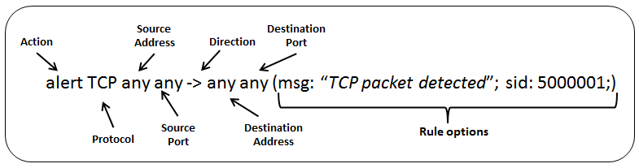

Figure 24 Rule Structure

In the image above, you can see a general structure of a snort rule. A deeper look into both parts of it, the header and the options, should make things more clear.

Rule headers consist of 4 basic fields, which include multiple sub-options: The rule action field, the protocol field, the IP addresses field and the direction operator field.

**Rule Action field** consists of 8 possible options that can be used:

* Alert: produces an alert based on the rule options
* Log: Logs packets
* Pass: Ignore packets
* Activate: Produces an alert and activates a dynamic rule
* Dynamic: Rules that stay idle until activated by an “activate” rule
* Drop: Logs and drops packet (Inline mode)
* Reject: Logs packet, drops it and sends a TCP reset message. In case of UDP, it sends an ICMP port unreachable message.
* Sdrop: Drops packet without logging.

**Protocol field** has 4 possible options, depending on which protocol’s packets you want to monitor: IP, TCP, UDP or ICMP.

**IP addresses field** includes information about the source and destination IP addresses the rule should be activated for, together with specific ports. The attribute “any” can be used in both addresses and ports, if the user wants the rule to scan all packets of specified protocol.

**Direction Operator field** implements the direction of the packets, for which the rule is valid. The operator “->” represents packet movement from the source address to the destination address, while the “<>” operator represents bidirectional movement scanning. The operator “<-“does not exists, since rules are read with consistency.

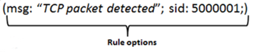

Figure 25 Rule options part

Rule Options are categorized into 5 categories, depending on their functionality: General Rule Options, Payload Detection Rule Options, NON-Payload Detection Rule Options, Post Detection Rule Options and Rule Thresholds. Because of the number of keywords per option, and their vast capabilities, I will not fully analyze them and skip a few, for the sake of avoiding unnecessary information. For further information on them, you can visit the Snort website.

**General Rule Options** offer information about the rule, but do not offer any active actions. Theymake use of the following keywords, which are separated with a”;”

* Msg: informs the logging & alert engine to produce a text string, along an alert or log.
* Reference: offer references to external identification systems.
* gid: Optional keyword that identifies which part of Snort generates an event. GIDs under 1,000,000 are used by Snort, therefore can cause conflicts if used by the user.
* sid: Rule identification keyword. Can be used along the “rev” keyword.
* Rev: Identifies revisions of Snort rules. Should be used along “sid”.
* classtype: categorizes attacks into attack classes, which are predefined by the software.
* priority: Indicates how severe a rule event is.
* metadata: includes additional info into the rule.

**Payload Detection Rule Options** search inside packets for specific payload content.

* content: allows the user to look for specific content inside a packet and can use special modifiers to make the search even more specific. Can be text and binary data.
* protected_content: similar to “content” but, utilizes hash algorithms to show encrypted content. SHA256, SHA512 and MD5 are currently supported.
* rawbytes: allows the rule to ignore encoded data and search for raw packet dara.
* depth: specifies how far inside a packet the rule should look for specific information.
* offset: offsets the start of the packet inspection by a specified amount of bytes.
* distance: specifies how much information the rule should ignore before beginning to search for information inside a packet.
* isdataat: checks if payload has data at a specific location.
* pcre: allows rules written in pcre (perl compatible regula expressions)
* byte_test: looks for bytes and binary values.
* ftpbounce: searches for FTP bounce attacks
* preprocessor rules: Rule options that have to do with different preprocessor functions.

**NON-Payload Detection Rule Options** search for non-payload content inside a packet

* ttl: searches for packets with specific spectrum of IP time-to-live values.
* fragoffset: searches for fragment offsets inside the package
* tos: checks IP TOS value
* id: checks IP ID value. This is specifically useful, since some hacking tools use specific values for this packet field.
* iports: checks for IP options.
* fragbits: checks for fragmentation and reserved bits which are located in the IP header
* dsize: checks payload size. Especially good for dealing with overflows.
* flags: searches for specific TCP flags
* flow: allows the application of rules in specified traffic directions
* flowbits: checks the state of app protocols.
* seq: searches for TCP sequence values.
* ack: searches for TCP acknowledge values.
* window: searches for TCP window size values.
* itype: searches for ICMP type values.
* icode: searches for ICMP code values.
* icmp_id: searches for ICMP ID values.
* icmp_seq: searches for ICMP packet sequence values.
* rpc: looks for RPC applications.
* ip_proto: looks for IP protocol heafers.
* sameip: looks if the source and destination IP addresses are the same.

**Post Detection Rule Options** are triggered after a rule has been activated.

* logto: makes Snort log all packets that trigger this rule into a special file.
* session: logs user data from TCP sessions.
* resp: activates response that kills suspicious sessions. Can be used in both inline and passive modes.
* react: activates response that also sends content to the user before killing a session.
* tag: tells the rule to log additional traffic and data regarding the packet that triggered it.
* replace: replaces content with a provided string. Can only be used in inline mode.
* detection_filter: defines a number of limits which trigger a rule when exceeded.

**Rule Thresholds** are thresholds that refer to the generator and SID they apply to, and can function alone or as part of a rule. They have the following format:

threshold: \

type <limit|threshold|both>, \

track <by_src|by_dst>, \

count <c>, seconds <s>;

Where:

* type: “limit” produces an alert on the 1st event that triggers the rule, then ignores the rest in its time limit, “threshold” produces an alert on every event and “both” produces an alert every time X events occur.
* track: tracks count of events based on source or destination IP.
* count: # of triggered rules in s seconds that will trigger an event.
* seconds: time in which “count” limit must be exceeded to produce and event.

Example:

The following rule produces a log on the 10th event of that SID in a 60 seconds period. If less than 10 events happen within 60 seconds, nothing happens.

alert tcp $external_net any -> $http_servers $http_ports \

(msg:"web-misc robots.txt access"; flow:to_server, established; \

uricontent:"/robots.txt"; nocase; reference:nessus,10302; \

classtype:web-application-activity; threshold:type threshold, \

track by_dst, count 10 , seconds 60 ; sid:1000852; rev:1;)

## IPS Mode

Snort’s IPS mode is called “Inline mode”. In this mode, Snort bridges two, or more, network interfaces and monitors the traffic passing through them. Additionally, checking traffic against already mentioned rules, inline mode introduces a new category of rules, which can drop packets. Because inline mode creates a bridge between two, or more, network segments in pairs, traffic won’t be able to pass nor be monitored between unbridged interfaces. For example, if you bridge eth0 with eth1, and eth2 with eth3, traffic won’t be able to pass between not-bridged interfaces, like eth0 with eth2 or eth1 with eth3.

In the following steps, I will show you how to set up Snort in Inline mode, using the DAQ AFpacket. Keep in mind that some rule actions and options can only be used in inline.

First, we have to configure the interfaces we plan to bridge accordingly, turning promiscuous mode on and disabling LRO and GRO. You can see all the available interfaces by using the “ifconfig –a” command.

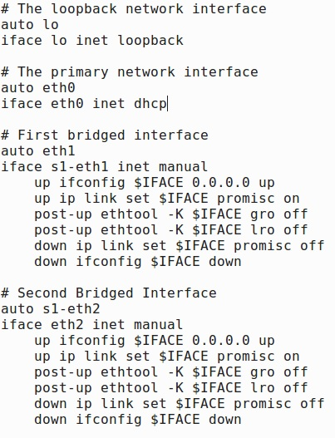

Figure 26 Inline mode network configuration

Now, we should confirm that afpacket DAQ is available, by running the “snort –daq-list” command.

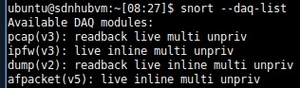

Figure 27 Snort DAQ Libraries

Then, we need to modify the snort.conf file, to make snort run in inline mode using afpacket.

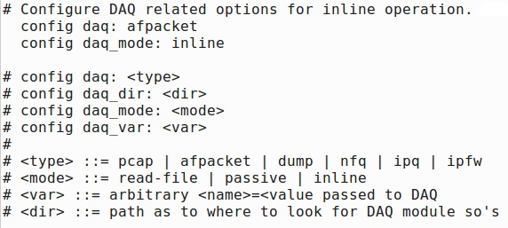

Figure 28 snort.conf Inline mode configuration

Finally, we need to verify the changes in our .conf file. Run the “sudo snort -T -c /etc/snort/snort.conf -Q -i s1-eth1:s1-eth2” command. For multiple interface bridges, you can use the following command as template “sudo snort -T -c /etc/snort/snort.conf -Q -i eth1:eth2::eth3:eth4”

Finally, we will set up a test rule set, and test it out. I will use the myrules.rules file and add the rules shown in figure 29, which will alert us if ICMP packets bigger than 100 bytes are detected, and will block packets bigger than 900 bytes.



Figure 29 Inline mode test rule set

Now, I can start monitoring our network using the command shown in figure 29.



Figure 30 Snort console network monitoring command

After running this command, some logs should pop up very fast, and the console should end up showing this result.

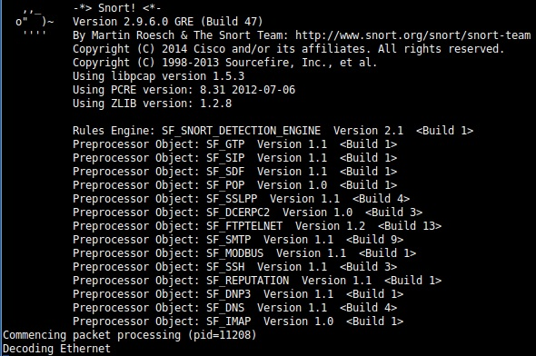

Figure 31 Snort default start screen

Now, to test our rules results, I will ping one host from the other host using packets bigger than 900 bytes, to which the mentioned interfaces correspond, and see the results.

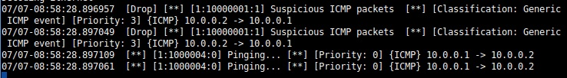

Figure 32 Alerts produced by Snort, according to our rule set

As we see in figure 32, Snort produces two alerts: 1 kind that alerts us about the dropped packets, and 1 kind that informs us about the regular ping that was not dropped.

To switch from inline mode to passive mode, we just have to undo the configurations we just did.

* + 1. Part four: Using Mininet with native controller and Ryu

## Installation

After installing the SDN Hub VM and setting up Snort and its rules, it’s time to see more about the main component of this experimentation: Mininet. Like I said in chapter 5.1, Mininet is an open-source, free network emulator for SDN which utilizes custom topologies to set up fully functional virtual network components, from switches to live hosts. This makes it a very versatile tool for research and learning that is very hard to ignore.

There are 3 ways to install Mininet: install it as a VM or natively from Source and Packages.

The first method is the easiest of all, since the only thing that has to be done is download the VM image from the official Mininet website, load it on your hypervisor and then follow the walkthrough, available at the official website, for further customization and understanding. While this is a very easy way to get you started on Mininet, it can also be a bit limiting. First of all, Mininet does not offer a GUI; it is solely controlled from CLI, with the exception of MiniEdit, a python application that allows the user to create custom topologies using a graphical interface. This can be a bit harsh for new users, especially if they want to explore premade topologies inside the system, or load their own. Another issue is connectivity. Trying to use a remote controller on Mininet, or multitasking inside its Ubuntu OS can be a bit challenging. While none of those can cause serious issues, using a remote controller from a different VM can sometimes fail, because Mininet will be unable to locate the controller, while multitasking can only happen by connecting to the OS through SSH sessions, and only CLI. If you do not plan on combining Mininet with something too serious, or if using only CLI does not scare you, this method should be perfect.

The second and third methods are pretty similar and are used in case you want to install Mininet as an application inside a Linux OS or VM. Both are well suited for Ubuntu installations, since they support the latest OVS versions and releases.

For the second method, you need to follow the steps bellow and use the necessary commands.

First, download the source code:

git clone git://github.com/mininet/mininet

If you want to download a previous version of Mininet, you can use the following commands instead:

cd mininet

git tag # list available versions

git checkout -b 2.2.1 2.2.1 # or whatever version you wish to install

cd ..

When this is done, install Mininet (In the “[options]” part, you can use “-a” to install everything included in the Mininet VM, including POX controller and Wireshark set up for OpenFlow, “-nfv” to install OpenFlow and OVS and “–s [foldername]” to install Mininet in a custom folder. The last option should be used in addition to the other two.):

mininet/util/install.sh [options]

In case you need more information about the installation, use this command:

install.sh –h

Finally, when everything is done, you can test Mininet by creating a simple topology and pinging all its nodes:

sudo mn --test pingall

The third, and final version, is about installing Mininet from packages. First of all, if you have a previous version of Mininet or OVS, you have to make is is purged completely:

sudo rm -rf /usr/local/bin/mn /usr/local/bin/mnexec \

/usr/local/lib/python*/*/*mininet* \

/usr/local/bin/ovs-* /usr/local/sbin/ovs-*

Then confirm the OS version:

lsb_release –a

Now, after purging everything, you can install Mininet using the following commands, according to your OS version:

Mininet 2.1.0 on Ubuntu 14.04/14.10: sudo apt-get install mininet

Mininet 2.0.0 on Ubuntu 12.04: sudo apt-get install mininet/precise-backports

After this is done, deactivate the OVS controller and test your installation:

sudo service openvswitch-controller stop

sudo update-rc.d openvswitch-controller disable

sudo mn --test pingall

If OVS does not work, try rebuilding its kernel module:

sudo dpkg-reconfigure openvswitch-datapath-dkms

sudo service openflow-switch restart

Finally, you can check out the Mininet walkthrough and download additional software.

In my case, Mininet came pre-installed in the SDN Hub VM, therefore I did not bother installing in on it. The only method I tried was the first one, hence the tips from my experience on it. Now let’s see how we can utilize Mininet to run custom topologies and use a remote controller, instead of the default OVS, to make our network functionals. [47]

## Usage and commands

Now that we have installed and configured Mininet, it is time to start setting up topologies and tweaking their characteristics. The first, and most basic, command of Mininet is the following, which will start Mininet and create a topology with 2 hosts and 1 switch:

sudo mn

When you execute this command on the CLI, Mininet will create that topology, and prompt you to the Mininet command prompt, where you can execute Mininet commands.

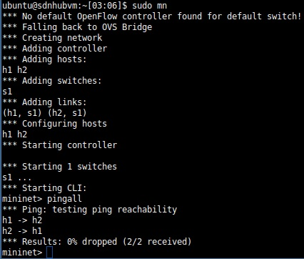

Figure 33 Mininet basic command and "pingall" command

After creating this topology, you can type and run Mininet commands on the Mininet CLI. Some examples could be:

-help: shows Mininet commands

-nodes: shows network nodes

-net: shows links

-dump: clears information about nodes

-pingall: pings all nodes

The last command will make all hosts ping each other, and Mininet will show you how successful the packet transfer was. You can be more specific on your pings by typing commands of the type “h1 ping h2”. You can also view each node’s network interfaces by typing “h1 config -a”. Keep in mind that each node’s active interface is not discoverable by the Linux system it is running on, compared to the switch’s interface it is connected on, which can be seen by the system. To view that interface, you can simply use “s1 ifconfig -a” on the Mininet CLI.

Finally, since Mininet emulates every network node as a fully functional system, it is possible to connect to each node through an SSH connection, using xterm. To do this, you simply use “xterm [node name]”, and a new CLI window will pop-up.

When you are done with your experimentations, you can type “quit” to exit Mininet. After this, or when Mininet crashes, it is suggested you run the clearing command, in order to delete any leftover virtual nodes:

sudo mn -c

Of course, this is not the end of Mininet’s capabilities. We can parametrize its starting topology further, by adding a few attributes. By adding the attribute “—topo” in the “sudo mn” command, we can load pre-included topologies or custom topologies. For example, you could load a single topology, where 3 nodes are connected to one switch like this:

sudo mn --topo single,3

Or a topology where each node is connected to one switch, called Linear:

sudo mn --topo linear,4 [49]

## Using a remote controller - Ryu

Another useful feature Mininet has is that it allows the use of a remote controller, a controller different from the included default one, which can be running locally or remotely. In order to utilize this feature, we must use the “controller –remote” parameter, as it can be seen in the following command, which is used to launch Mininet with a remote controller:

sudo mn --controller=remote,ip=[controller IP],port=[controller listening port]

Before we use this feature, we need to install a controller, either locally or in another machine/VM.

In my case, I experimented with Ryu controller, a component based framework written in Python, which was easy to use and very transparent when it came to development and tweaks. If you use SDN Hub VM, it comes pre-installed in it but, installing it on your own is easier than saying “1-2-3”. To install it, just use the following pip command:

pip install ryu

In case you want to install in from source:

git clone git://github.com/osrg/ryu.git

cd ryu; python ./setup.py install

Now, we should test if everything works as it should. First, we should create a Mininet topology, that will use a remote controller:  
sudo mn --topo single,3 --controller remote

As you can see, I have not included am IP address nor a port, since I will be running my controller locally. Mininet should locate my controller automatically.

Next, we should run Ryu, by going to its installed file and running the necessary apps, as seen here:

cd /home/ubuntu/ryu && ./bin/ryu-manager --verbose ryu/app/simple_switch.py

This will launch the OF Protocol Handler and Simple Switch 1.0 applications. You can choose multiple Ryu applications in one sessions, even in different CLIs.

Next, you should try pinging your hosts from Mininet, by using the “pingall” or “h1 ping h2” commands. When you do, you should see that all hosts are successfully pinged, while the Ryu window will have information about the traffic which was just sent.

In case you want to view the topology you just created on a browser window, it is possible by using the gui_topology.py script, after you have launched Ryu with a Mininet topology. To do so, you can use the following command:

sudo PYTHONPATH=. ./bin/ryu run --observe-links ryu/app/gui_topology/gui_topology.py

After this, you can use any browser and type “http://[Ryu host ip address]:8080”. This, should prompt you to the web GUI.

Finally, I should mention how easy it is to create your own Ryu application. Since everything is written and set up in Python, all you must do is use the right libraries and use the correct commands, to write your first application with just 4 lines of code. In my experiments, I utilized a custom script, offered by the Ryu creators, to monitor packet and byte count from the controller.

Since I did not utilize all the features of Ryu, I am not going to include more information about it, but, if you are interested, I highly suggest you to use their tutorial, which is very guiding. [49][50]

* + 1. Part five: Firewall set up and rules

Now, I should get more detailes about the IPS part of my experimentations. The first part of my IPS implementations inside the SDN infrastructure I will showcase is the default firewall iptables program, with the second part being my python script, which combines Snort alerts and iptables rules. The first part, the iptables, work mainly by utilizing a set of tables, which contain arrays of rules, with which a packet is compared. Based on those rules, specific actions are taken.

Iptables, as a program, is preinstalled in most Linux kernels by default, therefore no further installations were performed. In order to view the existing rules inside the tables, you can simply use this command:

sudo iptables –S

sudo iptables –L

In case you would like to preserve the changes, you have made, after reboot, there is a way to do this, since iptables do not do this out of the box. By utilizing the “iptables-persistent” package, iptables will now be able to save all the existing and new rules to a file, so they can be used after a reboot.  
sudo apt install iptables-persistent

Since I will be working with these rule sets, I will further analyze them, for better understanding of how everything works. Keep in mind that there are two different commands for iptables, since there are two versions of the Internet Protocol: iptables and ip6tables, for IPv4 and IPv6 respectively. Both work similarly, therefore the instructions bellow cover both.

As I have mentioned in previous chapters, there are 4 tables responsible for containing chains of rules:

* **Raw**: works with packets before their state is tracked.
* **Nat**: allow the change of packet routing in individual packets on NAT networks
* **Mangle**: allows the alternation of packet headers
* **Filter**: default table that makes decisions on whether a packet should go to its destination or not.

When a packet arrives to our system, iptables compare it against these rule chains. Their function is to filter packets. There are 5 preset rule chains:

* **PREROUTING** chain: contains rules that apply to packets that have just arrived and have not been processed localy.
* **INPUT** chain: contains rules that apply to packets that have just arrived and are about to be locally processed.
* **OUTPUT** chain: contains rules that targets packet outputs from a local process.
* **FORWARD** chain: contains rules that target packets that are routed through the system.
* **POSTROUTING** chain: contains rules that target packets that have just left the network interface.

In Figure 34, you can see in which tables each rule chain is present at, and at what point inside our network they function.

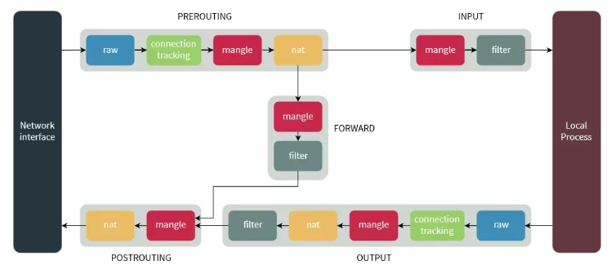

Figure 34 Rule chain datagraph

When the packet is matched against a rule, the program utilizes Targets, which prompt it to take specific actions. If no match happens, iptables utilizes its default policy chain and takes whatever action it implies. Those can be terminating rules, which take immediate actions, or non-terminating rules, which continue to match packets with other rules, even if there is a match. There 3 terminating targets, that are used the most often:

* **ACCEPT**: prompts iptables to accept packets
* **DROP**: prompts iptables to drop packets, making the system invisible as a destination.
* **REJECT**: rejects packets, sending a “connection reset” packet for TCP connections and “destination host unreachable” packet for UDP or ICMP.

Non-terminating target examples could be LOG target, which logs incoming matching packets, but those packets will still get filtered by other rules as well.

Now, let’s see some rule examples. [48]

## Blocking and accepting Traffic

One of the most usually used action that also represents the main function of a firewall, is the action that blocks traffic. Let’s say you have company network segment with a range of 10.0.0.0 to 10.0.0.255.

In case you want to block all incoming traffic from, let’s say 10.0.0.56, to your pc, you can easily do this by utilizing the INPUT chain, included in the filter table:

iptables -t filter -A INPUT -s 10.0.0.56 -j REJECT

In this command, “-t” indicates the table we are using, “-A” cause the new rule to be “appended” into the end of the INPUT rule chain (-A can be replaces by –I, for inserting rules at the beginning of a chain). The “-s” stands for source address. And “-j” indicates which target iptables should use. Since the filter table is used by default, we can skip the “-t filter” if we want to.

Now, let’s say you want to quarantine your computer from the network completely. You can do this by selecting a range of source addresses like that:  
iptables -A INPUT -s 10.0.0.0/24 -j REJECT

Finally, you can block outgoing traffic, using the OUTPUT chain:  
iptables -A OUTPUT -d 10.0.0.56 -j DROP

The “-d” stands for destination address. You can also use “-s”, if the system you are using filters traffic on a switch or at some central network point.

Additionally, you can enhance your rules, by adding specific ports and protocols you want them to look for. For example, let’s say we want to block all incoming TCP traffic:

iptables -A INPUT -p tcp -j DROP

We are using the same attributes as before, except for “-p”, which allows to add the protocol we want.

Likewise, we can add ports to our rules:

iptables -A INPUT -p tcp -m tcp --dport 22 -s 10.0.0.0/24 -j DROP

In this example, we want to block all inciming SSH connections in port 22. Therefore, we chose to block TCP traffic using the “-p” attribute, then we load the tcp module using “-m” and finally we use the “—dport” to specify the port traffic we want to block is heading to. Similarly, we can do this with UDP, ICMP etc, while we can choose more than one ports at the same time, like this:

iptables -A INPUT -p tcp -m multiport --dports 22,5901 -s 10.0.0.0/24 -j DROP

In that case, we used the multiport module, in order to use multiple ports at once.

Finally, we can include specific interfaces to our rules, in order to lighten the burden on each rule chain. This can be very useful, especially in web servers, where communication with the localhost can happen through the loopback interface (lo).

Like in the protocol example, we can specify which interface the rule should filter traffic from, by adding the “-i” parapemeter and specifying the interface.

So, let’s say we want to accept all incoming traffic arriving at the loopback interface:

iptables -A INPUT -i lo -j ACCEPT

Similarly, if can reject traffic going to or leaving from a specific interface, from a specific source or destination address:

iptables -A OUTPUT -o wlan0 -d 10.0.0.55 -j DROP

iptables –A INPUT –i wlan0 10.0.0.0/24 –j DROP

Note that when we want to target outgoing traffic, from a specific interface, we use the “-o” parameter instead of “-i”. [48]

## Listing, deleting and replacing rules

Knowing how to insert rules inside your rule chains is important but, being able to see what has been inserted in each chain is also essential, from just viewing the inserted rules to deleting or replacing them.

To list all the inserted rules, with their respected line numbers, use the following command:

iptables -L --line-numbers

This should print 3 basic rule chains, the INPUT, FORWARD an OUTPUT. If you want to see chains included in a different table, you can use the “-t” parameter to specify which table you want to view.

After viewing what rules each chain has, you can either delete them or replace them. To delete a rule, you can either by typing the full rule, and replacing the parameter in your command, before the chain specifier, with “-D” or by using the rule’s line number:

iptables -D INPUT -s 221.194.47.0/24 -j REJECT

iptables -D INPUT 2

Similarly, you can replace a rule, by using the “-R” parameter, instead of “-D”, and specifying the rule chain and line number of the rule, followed by the changes you want to make on the rule in that line. For example, let’s say you want to change the source address on the rule that is on line 2 of the INPUT chain, and want to change the source address from 59.45.170.10 to 59.45.170.12:

iptables -R INPUT 1 -s 59.45.175.12 -j ACCEPT

[48]

* + 1. Part six: Python SnortIPS script

Finally, we reach the second, and last, part of my IPS implementation: the Python SnortIPS script. By utilizing the Python scripting language and its huge variety of libraries, I was able to write an advanced script that implements CLI commands, in order to simplify and increase the speed of specific actions. The reason why this script was created was because of the inability of Snort’s IPS mode to function properly in SDN networks (This will be seen in more detail on chapter 8. Let’s analyze how it works, what libraries it utilizes and how one can tweak the code in order to adjust it to his/her needs.

The basic idea behind this script was to utilize Python libraries to implement CLI commands. To achieve this, I used Pexpect, a python module that spawns other applications as childs and allows the control of them through it. It is especially useful if you want to automate CLI procedures, like SSH, FTP etc. and setup scripts in different hosts, in order to execute specific actions. In my case, I combined it with Snort, and used it to read its alerts and insert firewall rules based on the incoming alerts and the administrator’s choices.

To be able to use this module on any python script, you have to install it using pip:  
pip install pexpect

After installing it, its usage is very simple. You only have to import it in your script, as you will see in a while.

To create a child, which will refer to the application you want to start and control, you need to use the pexpect.spawn() command and assign it to a variable. After you spawn your child-application, the pexpect has two main procedures you will use the most to control it: **expect()** and **send()/sendline().**

The first procedure expects the application to return a specified string, while the second one sends a specified string back to the child-application. After using the expect() method, you can use the “before” and “after” properties to either get all the text up to the specified string or only get the text that matched the specified string, respectively. In figure 35, you can see an example where the user partialy automates the usage of an FTP server, and then gains control over the application.

When you try to match a specified string, Pexpect will always return a minimal match. If you want to return just one character, you can use the child.expect ('.+') and if you want to match as little as possible, you should use the child.expect ('.*').

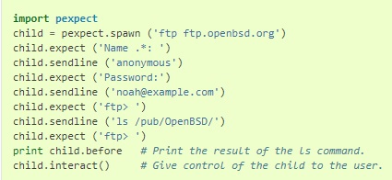

Figure 35 FTP server control through Pexpect [51]

Α very important property you should keep in mind is the TIMEOUT property, which allows you to set the time before a timeout exception is generated on a session, according to your needs. For example. Let’s say you try to create a child-application and it is not responding or it is taking longer than 30 seconds to start. Then, by default, Pexpect will throw a timeout exception after 30 seconds. In order to change the timeout time in any Pexpect procedure, you can use this attribute like this:

child.expect('password:', timeout=120)

Finally, there are the EOF exceptions and the EOL identification. For the later, since Pexpect reads one character at a time, when it comes to child output, in order to identify the end of the line of this output we use the DOS-style “\n” or “\r\n”. This way, Pexpect either “sees” the end of the line or “sees” the EOL and looks for a new one, for example child.expect('\r\n').

When a child-application has stopped working or it has stopped giving an output, he except() procedure will throw an EOF exception. In order to avoid this, we can use the expect(pexpect.EOF) method. We can also use this to catch such exceptions, in a Try…catch scenario as well, like this except pexpect.EOF:, in order to take specific actions in case the child-application stops sending output.

Now, let’s break down the basic structure of the script, which consists of 2 main parts: The IPS part, that detects Snort alerts and prompts the administrator to take preset actions, and the Firewall control part, which allows the user to insert firewall rules based on specific attributes. These are used based on user choice, through a selection input. If the administrator wishes, he can add similar sections in each part, to cover his/her needs.

The first part can also be divided into parts, depending on what kind of rules the administrator wants to implement. In my experiments, I focused on ICMP and TCP attacks for demonstration, therefore I separated my code into 2 parts, dedicated into each one of those. Those “parts” are a couple of “if…” statements, inside 2 while loops and one for… loop. The “while” statements are responsible for running the program and choice-making, while the if… statements, for each part, are responsible for matching with alert output from Pexpect or alerting the user, if specific flags reach a specific number. They can either look for individual alerts, or use a list, which is compared with the alert’s SID to look for bulk rules, for example TCP attacks.

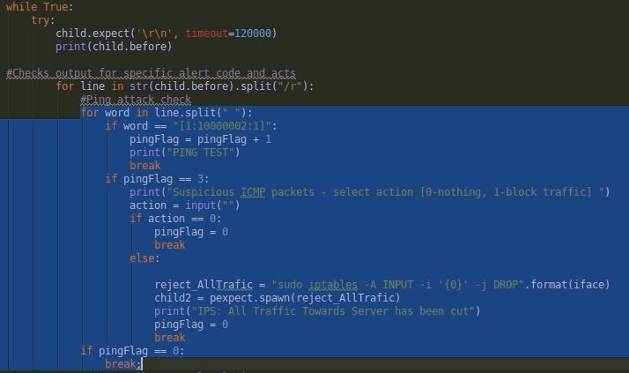

Figure 36 A section in the script, discovering 1 specific rule.

For bulk rule SIDs, for which we want to have the same action, we can use the structure seen in Figure 37, which utilizes a list of Snort rule SIDs.

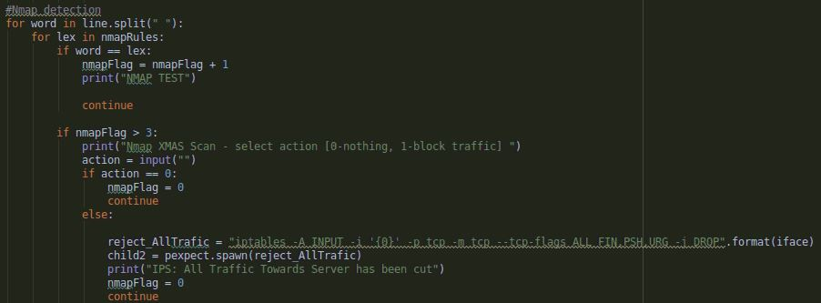

Figure 37 Bulk rule trigger structure

In general, the way the script triggers any IPS action is by using specific counter flags, which increase by 1 every time an alert with a set ID is recognized. These flags are usually named after the attack they are focused on, like “pingFlag” and they are what I will call a “threshold”, as seen in Figure 38.

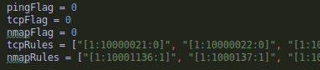

Figure 38 Script threshold flags and rule SID lists

In Figure 36 and 37, you see a section focused to look and take specific actions for a specific alert. After splitting the alert, using the “child.before” procedure, it searches for a specific alert ID, set in a variable or list. If this alert ID shows up, the threshold count raises. When it reaches the set threshold, the administrator is alerted that something is wrong and is prompted to take actions. In my example, the action is to cut all traffic towards the selected interface. By inserting a different CLI command, or by adding another option, the administrator can tweak the pre-selected actions.

Otherwise, after he gets alerted, he can insert his/her own in the next main part of the script, the firewall control. That part, which is the second one, consists of 4 options, based on how complicated the firewall rule the admin wants to insert is.

Bulk rule comparison works in a similar fashion, but instead of comparing incoming rule SIDs with a variable, the SIDs get compared with a list of rule SIDs, which will trigger actions after a specific alert threshold.

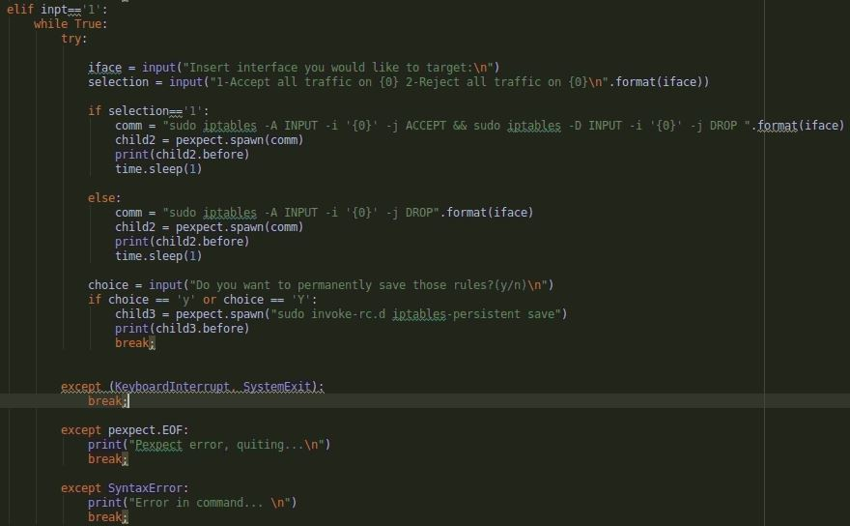

Figure 39 Choice structure of firewall control.

In Figure 39 you can see the 1st option, which allows the administrator to choose a specific interface to Accept or Block traffic. Each option, in the second part, has the same structure: it takes one or more user inputs, asks if the user wants to Accept or Reject traffic with the specified attributes and executes the necessary commands.

In practice, all these are executed in CLI by typing “sudo python [script path]” and have the following option, seen in Figure 40.

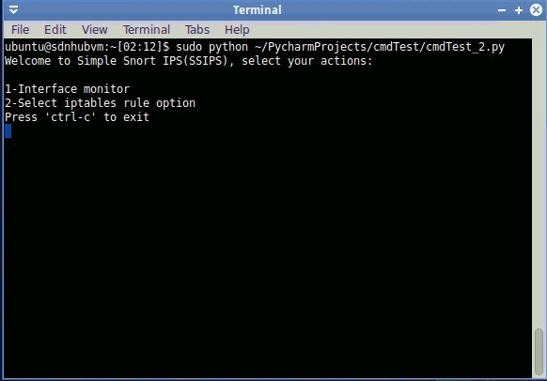

Figure 40 SnortIPS starting screen

By typing “1” or “2”, the user can either monitor or use iptables rules. If he/she chooses the “1”, he will be prompted to enter the interface he/she wants to monitor, and then Snort will be launched. Together with the Snort alerts, the administrator will receive custom outputs from the script, together with choice inputs, for IPS functions.

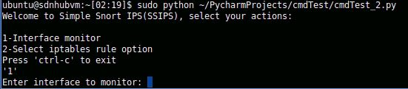

Figure 41SnortIPS interface selection

In the “2” case, the administrator will be prompted to select between 4 options, as seen in Figure 41. Each choice will include 1-3 inputs, depending on how many attributes are required.

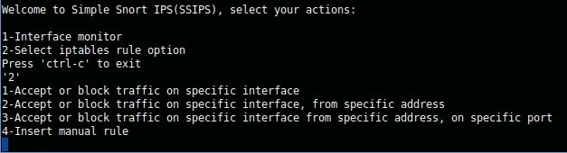

Figure 42 SnortIPS firewall options

Any input that does not comply with the available options will usually redirect the user to select an option again.

With these instructions, we can conclude myour guide for the tools I used. In the 6th chapter, I will show you the tests I run, together with the results, and make a conclusion in chapter 9. [51][52]

1. Simulations and Examples

In the final part of my thesis, I will showcase all the examples and cases I experimented with, step by step, and analyze the results. All the experiment’s goal is to show the effective integration of Snort, iptables, and the combination of those two through the Python script I developed, all of which are legacy tools, while monitoring traffic through the controller and using the results to add an extra layer of threshold security, by the monitoring administrator. I separated all my examples in 4 categories, depending on what software I used to detect or stop malicious traffic.

As a first mean of defense, I used an included monitoring tool, embedded on the Ryu controller, which shows us incoming and outgoing packets and bytes from all available ports, as well as incoming and outgoing packets and bytes from each flow. Each switch can be identified in the “datapath” column, where its ID is shown, while the rest of the columns are straight forward. An example of the monitoring interface can be seen in Figure 43 bellow.

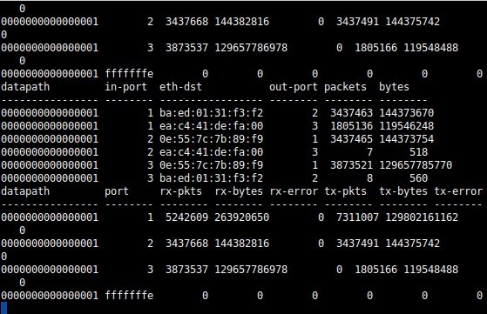

Figure 43 Ryu Simple Monitor Statistics

For every example, except for the whole 2nd experiment, I used the same ruleset, which I made on my own and consists of personal rules, as well as rules I found online, and switched between different intrusion detection and prevention methods. In Figure 44 you can see the ruleset I am using for the biggest part of my experimentation, when it comes to Snort.

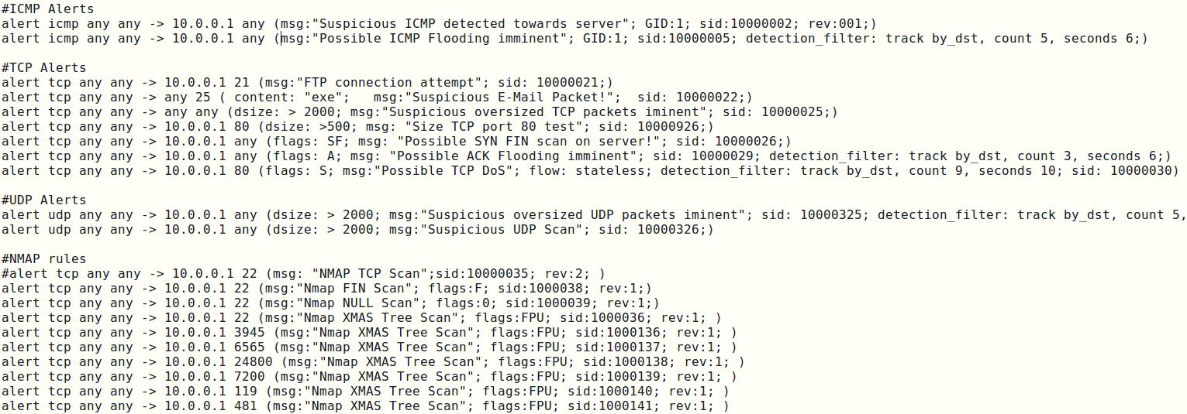

Figure 44 Custom Snort rules example

To simulate my software defined network, I set up a single topology of 3 hosts, which are connected on a single switch.

Each host can represent a network user, a “server” or a malicious host from which attacks will happen, all depending on the example. For my experiments, I consider Host 1 (10.0.0.1) as our network’s “server”, Host 2 (10.0.0.2) as the malicious user, and Host 3 (10.0.0.3) as a typical user who is trying to connect with Host 1. In Figure 45 you can see 2 topology examples, made by Mininets GUI “Miniedit”, showing a single topology of 3 hosts on a switch, on the left, and a linear topology of 4 hosts connected to 4 switches, which are then connected with each other, on the right. For my experiments, I used the topology on the left for simplicity purposes.

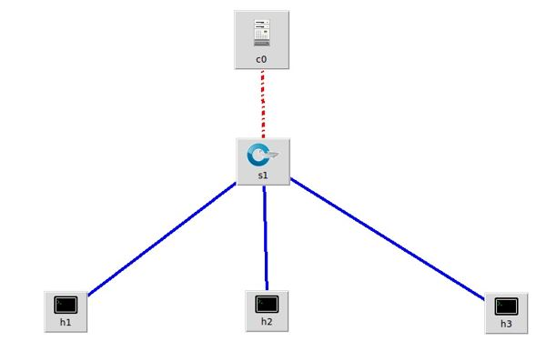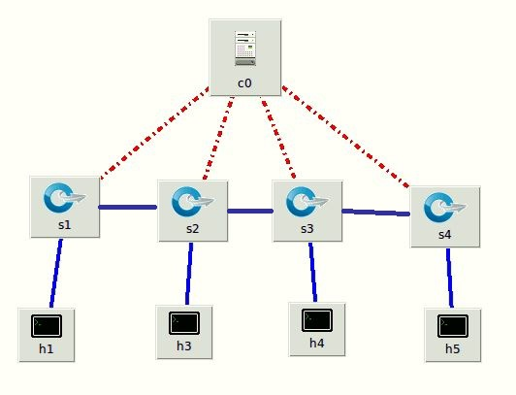

Figure 45 Single and Linear topology examples on MiniEdit

Something I should pinpoint is that Snort and Wireshark were turned on to monitor Host’s 1 connected switch interface, called “s1-eth1”. If the user decides to monitor Host 1 locally, he/she will have to monitor Host’s 1 local interface “h1-eth0” but, will be unable to see all other interfaces.

* 1. Example 1: Snort IDS mode

I start by implementing Snort, on its own, as an IDS in my virtual infrastructure for IDS purposes, with the scenarios you will see below, while monitoring everything with the statistics from the controller. Other than Snort, the administrator can use the statistics from both Wireshark and the controller to detect an attack. I’ve also measured the CPU usage of Host 1 before, during and after the attack, using the tool “top”. The bandwidth between each connection was measure using iperf, a reliable network packet generator. The connection between Host 1 and Host 3 is a TCP connection.

## 1st case: ICMP Flooding

In this case, I will showcase a simple ICMP flooding, where I ping the network’s “server” with big ICMP packets, while measuring the connection between the server and a client. This can cause issues, if the server has a big load to process or has to service many clients. In this example, Host 1 (10.0.0.1) is the target. In my Snort rule set, I set 2 rules corresponding to this case: one that produces an alert when Snort receives ICMP packets, which could be skipped, and one when it receives 5, or more, ICMP packets, within 6 seconds, to indicate packet flooding.

To monitor Host 1, I have launched Snort, while using the controller’s monitor tool for statistics.

To produce the ICMP flood, I used the “hping3” software, which is a packet generator with multiple capabilities, including the ability to flood a target, like this:

sudo nping –icmp 10.0.0.1 --flood

As shown in Figure 46, immediately after Host 1 (10.0.0.1) starts receiving ICMP packets, Snort start alerting me based on the rules I set. After exactly 5 alerts within less than 6 seconds, a second alert was generated, which informed us that an ICMP Flooding was imminent, since the server was receiving multiple ICMP packets from the same IP address, seen on the mentioned figure bellow.

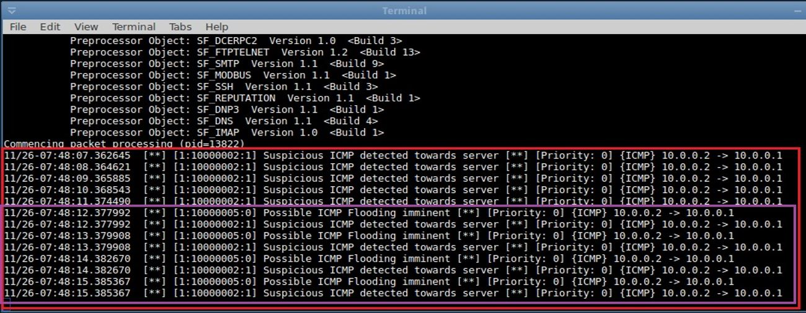

Figure 46 ICMP Flooding alerts

Knowing that there is an issue, I can go straight to the statistics drawn straight from the controller, where I will see there is an issue: the incoming information from Host 2 towards Host 1 has skyrocketed from mere 238 bytes to a total of 43748 Kbytes, on the link between Host 2 and Host 1, within 10 seconds, as seen on the controller packet monitor board, in Figure 47.

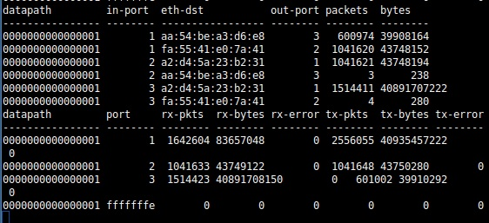

Figure 47 Packet statistics from the Controller

After confirming there is an attack, I can also check the bandwidth between Host 3 and Host 1, which has dropped by almost 50%, since Host 2 is consuming network resources to flood Host 1 with packets. The totality of the drawn statistics combined can be seen in Figure 48.

|  |  |  |  |
| --- | --- | --- | --- |
| # Test | Incoming bytes  (h2->h1) | Bandwidth  (H3->H1) | packet loss |
| Before | 238 | 8.95Gb/s | 0% |
| During | 43748kb | 5.05Gb/s | 1% |
| After | 43748kb | 11.3Gb/s | 0% |

Figure 48 ICMP Flooding Statistics

After the attack has stopped, the bandwidth comes back to normal, while incoming information from Host 2 stays the same, indicating that the attack has stopped, as seen in Figure 48 in the “After” section.

## 2nd case: TCP ACK header flooding

Similarly with the payload option, Snort can detect TCP packet headers. In this scenario, Snort is set to detect tcp packets with ACK header, when more than 5 incoming packets with the same destination address arrive within 6 seconds, in order to alert the user for possible ACK header attacks. Using hping3, again, I simulate a flood attack on Host 1, from Host 2, using the following command:

sudo hping3 10.0.0.1 –ack –flood

After 6 seconds from the beginning of an attack, Snort starts producing alerts about the ongoing ACK attack, as seen in Figure 49.

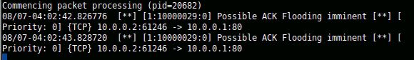

Figure 49 ACK flooding alerts

This can be confirmed by the controller statistics, seen in Figure 50, where incoming bytes from Host 2 to Host 1 have increased dramatically in a short period of time, which indicates that there’s a flooding of information. Of course, if Snort did not alert us, one could have considered this a typical big file transfer, therefore statistics alone cannot be considered solid.

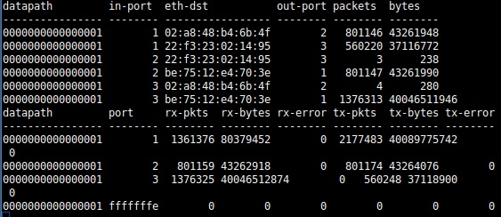

Figure 50 Statistics shown by the controller monitor

To confirm there is an attack going on, I also check the bandwidth between Host 3 and Host 1, using iperf. Quickly I realize there is indeed a flooding, since there is a drop of over 50% on said link. The entirety of the monitored data can be seen in Figure 51.

|  |  |  |  |
| --- | --- | --- | --- |
| # Test | incoming bytes  (H2->H1) | Bandwidth  (H3->H1) | packet loss |
| Before | 518b | 9.0Gb/s | 0% |
| during | 43261kb | 3.9Gb/s | 0% |
| after | 43261kb | 7.9 Gb/s | 0% |

Figure 51 ACK attack statistics

After the incoming packets stopped increasing, the administrator can assume the attack has stopped, and begin checks. You can see that, after the attack, the bandwidth had returned to almost normal levels.

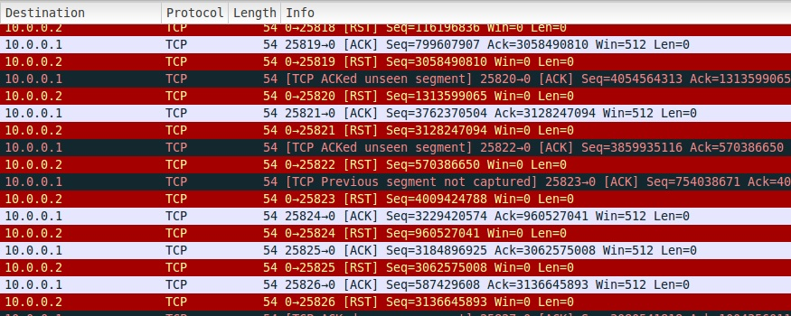

Figure 52 ACK Flood Wireshark results

In Figure 52, you can see the Wireshark’s packet capture of the attack, consisting of multiple ACK packets causing the server to send a reply, making its targeted port unavailable and confirming there was an attack.

Wireshark was not active while the statistics were noted, for the reason that it would significantly drop the bandwidth between the server and the client. In my case, this is not an issue, but it was observed and confirmed.

## 3rd case: TCP SYN DoS Attack

Of course, no test would be complete if I did not try a DoS attack, using SYN headers flooding. In this scenario, Host 2 (10.0.0.2) floods Host 1 (10.0.0.1) with tcp SYN header packets that do not relate to any 3-way handshake, while Host 3 is trying to establish a TCP connection with Host 1. This can be extremely dangerous, since the computer will wait for a response to the SYN packet it will have sent, in response, and the used port will be occupied, denying connection to other devices, on the targeted port.

In this case, the scenario goes a bit differently. Snort was not turned on when the attack started happening, in order to see how it affects bandwidth, and detection happened solely by watching statistics from the controller and bandwidth drops from iperf.

As seen in Figure 53, which shows packet and byte counts between each flow, there is a big number of bytes going from Host 2 to Host 1.

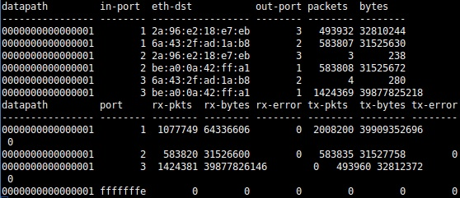

Figure 53 Controller monitor statistics

This sudden information increase causes suspicions, therefore a bandwidth check between Host 3 and Host 1 is run, to see if there is indeed resource consumption.

After iperf is done checking the bandwidth, a drop of almost 50% on the link between Host 3 and Host 1 is confirmed, as seen in Figure 54.

|  |  |  |  |
| --- | --- | --- | --- |
| # Test | incoming bytes  (H2->H1) | Bandwidth  (H3->H1) | packet loss |
| Before | 238b | 22.0Gb/s | 0% |
| during | 31525kb | 13.0Gb/s | 0% |
| after | 31525kb | 8.3 Gb/s | 0% |

Figure 54 Dos attack statistics

While this increase in incoming information is indeed suspicious, I cannot know for sure if it is an attack or not. Therefore, I fire up Snort, and immediately start receiving alerts about a possible DoS attack, based on a rule that gets triggered when TCP packets with ACK flag are received. The alerts can be seen in Figure 55.

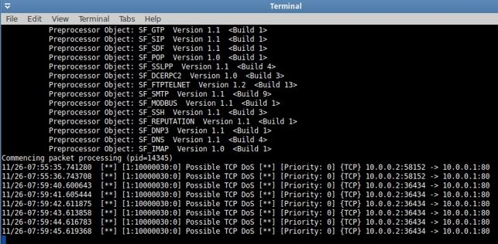

Figure 55 DoS attack Snort alerts

After the attack is complete, I stop receiving alerts from Snort, while incoming bytes from Host 2 stay static. But, I also notice that the bandwidth has decreased even further, compared to the bandwidth before and during the attack, forcing us to the conclusion that Snort greatly clutters my network speed. This is to be expected, since it filters all incoming packets.

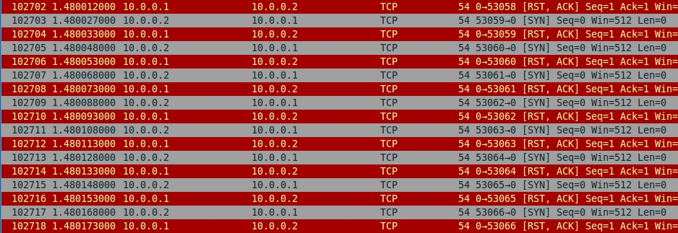

Figure 56 DoS packet composition on Wireshark

In Figure 56, you can see the packet analysis of the attack on Wireshark. The attack is like the ACK attack monitored case 2, forcing the targeted port to produce replies and become unavailable to other users.

## 4th case: Nmap XMAS and NULL port scan

Finally, I simulated the scenario of a TCP XMAS and NULL header scan. In general, a TCP port scan is used to determine whether a destination port is open, closed or filtered, by sending packets that are missing the SYN, RST or ACK headers. This way, if the port is closed, a packet missing those headers will cause a RST response from the target. If the targeted port is open, no response will be received and with this the software used by the attacker can tell the port status.

In my case, I used Nmap, a packet generator and port scanner.

The scenario goes as usual. I will measure statistics before anything happens, during Host 2 (10.0.0.2) port scans Host 1 (10.0.0.1), while Host 3 initiates a TCP connection, and after the scan is done. Snort is active during the whole duration of this experiment.

In Figure 57 you can see the alerts that get produced by Snort, indicating there is a scan, specifically an XMAS scan. The alerts are initiated when port 22 is scanned, but more alerts can be added to cover a bigger number of ports.

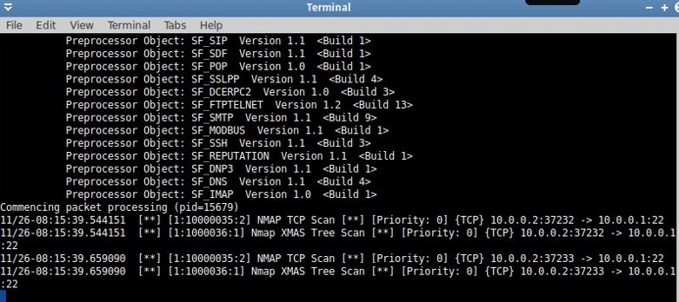

Figure 57 XMAS Scan Snort alerts

By immediately checking the controller measurements, seen on Figure 58, Ι can assume there is something wrong, since incoming bytes from Host 2 to Host 1 have suddenly increased. Of course, Ι wouldn’t be able to be 100% sure this was a suspicious action, from the monitoring alone, if I did not have Snort turned on, to see the alerts.

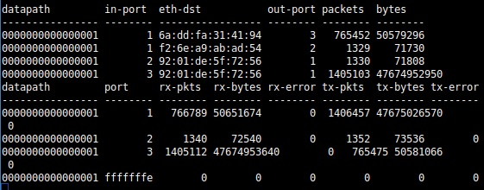

Figure 58 Statistics drawn by the controller after a XMAS scan

After receiving the necessary Snort alerts and confirming the information increase, I can start checking the bandwidth between other hosts and Host 1. As the scan is executed, I notice a slight drop on the bandwidth between H3 and H1, but nothing out of the ordinary, as seen on Figure 59. If it wasn’t for the Snort alerts, or Wireshark, it would be impossible to tell there was a port scan.

|  |  |  |  |
| --- | --- | --- | --- |
| # Test | Incoming bytes  (H2->H1) | Bandwidth  (H3->H1) | packet loss |
| Before | 280b | 14.1Gb/s | 0% |
| During | 71kb | 12.7Gb/s | 0% |
| After | 71kb | 13.3 Gb/s | 0% |

Figure 59 Total statistics

Figure 60 shows the Wireshark sniffing have also indicated that this was an XMAS port scanning, since it shows us incoming FIN,PSH,URG header packets, the packets that consist an XMAS scan, from Host 2.

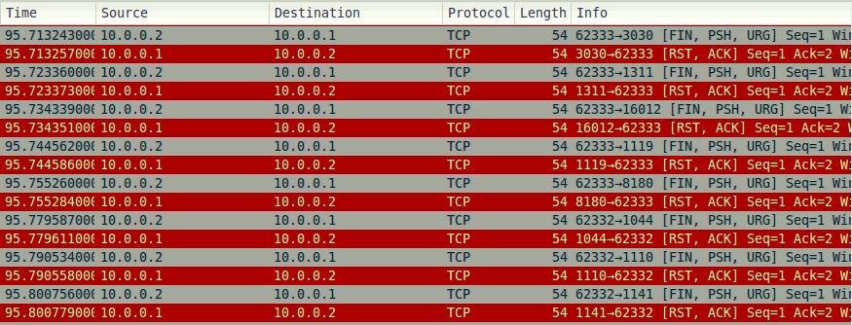

Figure 60 XMAS Scan Wireshark sniffing

On the attacker side, on Figure 61, we can see that port 5001, which is where the iperf has an open port listening to incoming requests, was successfully sniffed by the attacker.

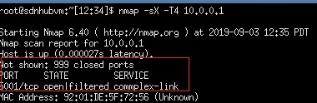

Figure 61 XMAS scan results

Similarly, with the previous scan, I also executed a NULL scan, which utilized NULL header TCP packets. In Figure 62 we can see the Snort alerts that came in, after the attack is initialized.

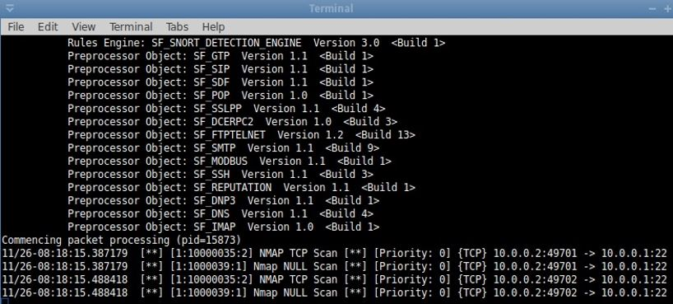

Figure 62 NULL scan alerts

After receiving the Snort alerts, I can confirm something is off, by viewing the monitoring statistics, as seen in Figure 63. The increase in sent information from Host 2 to Host 1 indicates activity out of the ordinary, but nothing too serious.

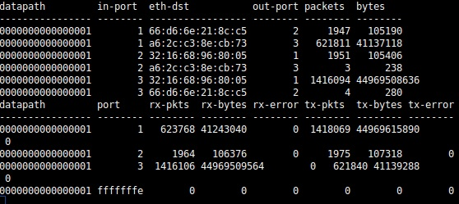

Figure 63 Statistics drawn from the controller after a NULL scan

By checking the link between H3 and H1, using iperf, I also notice a slight drop on the bandwidth but, again, nothing is out of the ordinary. In Figure 64, you can see the entirety of the gathered statistics before, during and after the scan.

|  |  |  |  |
| --- | --- | --- | --- |
| # Test | Incoming bytes  (H2->H1) | Bandwidth  (H3-H1) | Packet loss |
| Before | 423b | 8.9Gb/s | 0% |
| During | 105kb | 7.5Gb/s | 0% |
| After | 105kb | 8.4 Gb/s | 0% |

Figure 64 NULL Scan statistics

Figure 65 shows us the captured packets sent during the attack , with NULL header packets going from Host 2 to Host 1 and Host 1 sending back RST replies.

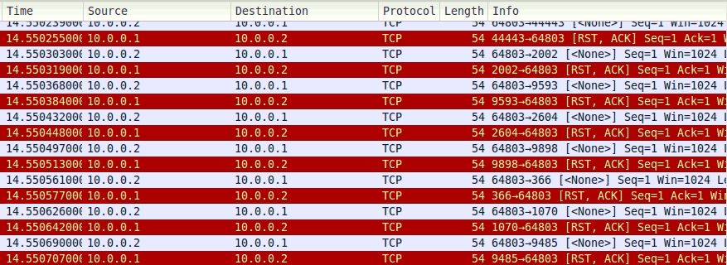

Figure 65 NULL scan Wireshark sniffing

From the replies nmap receives, at Host 2, it was revealed that port 5001 was open/filtered, as seen in Figure 66. This is indeed the port iperf is listening for requests, on Host 1.

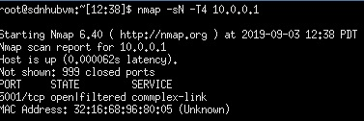

Figure 66 NULL Scan results

* 1. Example 2: Snort IDS mode & Linux Firewall rules

In order to continue my research on legacy IDS and IPS solutions on SDN, I decided to utilize a default Linux software called “iptables”, which is the included firewall rule software in Linux. As I described in previous chapters, iptables filter packets through a series of lists, which include user defined rules, in order to find if any packets that match a specific rule. When a packet is matched with a rule, a specific action is taken, depending on the rule’s action field.

In the following experiments, I wrote a few simple firewall rules and recorded the changes after a rule is implemented on the targeted Host, using Wireshark, monitoring on the controller and Snort, while executing the same experiments as in the previous Example.

Host 1 was used as a server, Host 2 was the attacker and Host 3 was used to simulate the behavior of a client connecting to Host 1 during an ongoing attack.

## 1st case: ICMP Flooding

Like in the last two experiments, I start with an ICMP flooding. I use Snort’s rules from Example 1, to detect the attack, while flooding Host 1 from Host 2 with ICMP requests. For the attack, I used the “hping3” program, like in the Example 1:

Sudo --icmp hping3 10.0.0.1 --flood

While the flood is initiated, I use Host 3 as mean to measure he available bandwidth with Host 1.

As seen in Figure 67, Snort instantly picks up the incoming flooding and bombards us with alerts.

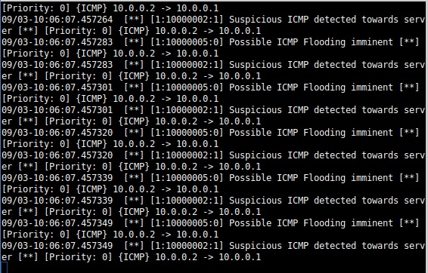

Figure 67 Snort alerts during ICMP flood

After I receive the alerts from Snort, I check the monitor results from the controller, seen in Figure 68, to see if anything is out of the ordinary. Indeed, information coming from Host 2 to Host 1 has increased greatly and out of the ordinary, indicating there is a flooding as Snort alerted.

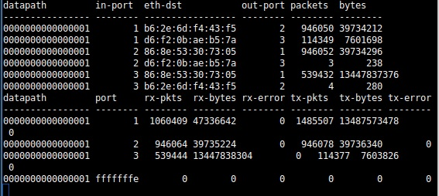

Figure 68 Statistics drawn by the controller during the attack

Using iperf to measure the bandwidth between Host 3 and Host 1 also confirms something is consuming network resources, since it has dropped by almost 48%, as seen in Figure 69.

|  |  |  |  |
| --- | --- | --- | --- |
| # Test | incoming bytes  (H2->H1) | Bandwidth  (H3->H1) | packet loss |
| Before | 240 | 8.68Gb/s | 0% |
| During | 39734kb | 5.05Gb/s | 0% |
| After | 86543kb | 9.33b/s | 0% |

Figure 69 ICMP flood test total statistics

Finally, checking Wireshark, as seen in Figure 70, you can see the incoming packets from Host 2, and also see that Host 1 is replying by sending “echo-replies” to Host 2, which cause network resource consumption.

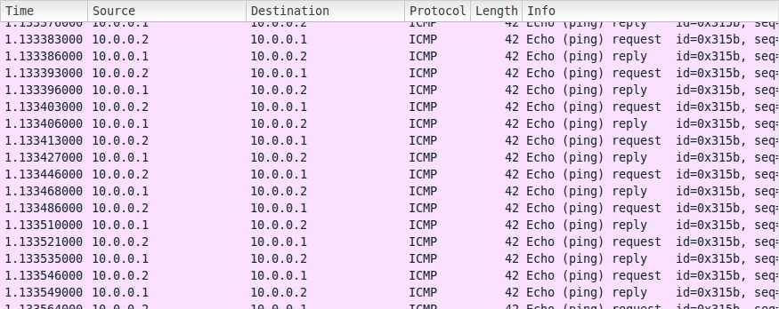

Figure 70 Wireshark ICMP flood before implementing firewall rule

To stop the flooding, I will use specific firewall rules, which technically will stop the flooding.

To stop the incoming ICMP requests, I used the following command, which targets incoming ICMP packets from the IP address 10.0.0.2, which Host’s 2 address:

iptables -A INPUT -p icmp -m icmp –s 10.0.0.2 -j DROP

This could also be substituted with a general blockage of ICMP packets, by just skipping the usage of a specific source address:

iptables -A INPUT -p icmp -j DROP

Indeed, after reinitiating the attack from Host 2 to Host 1, Host 2 receives no reply and considers Host 1 unavailable. Snort continues to show us alerts, since Host 1 still receives the ICMP packets but, there is nothing to be concerned of, since Host 1 will not consume any of its network resources replying to all the flood packets.

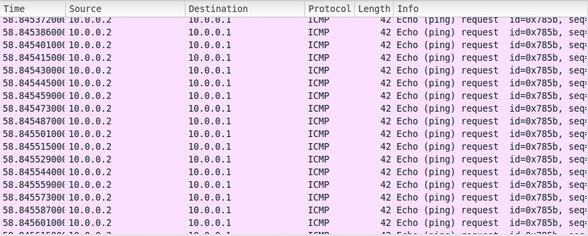

Figure 71 Wireshark report after the implementation of firewall rule

This can be seen in the bandwidth between Host 1 and Host 3 coming back to normal, in Figure 69, and in the Wireshark report in Figure 71. While packets from Host 2 do arrive at Host 1, and the byte count increases, Host 1 does not send any replies back.

## 2nd case: TCP SYN DoS Attack

Similar to the first case, I executed a TCP flooding on the target (Host A) with SYN header TCP packets, in order to trigger Snort and, at the same time, see how iptables would prevent, or stop, a DoS attack. The procedure I followed is the standard: fire up snort, initiate an attack from Host 2 to Host 1 port 80, measure bandwidth before, during and after the attack and see how my network reacts after the implementation of a firewall rule.

To generate said packets, I used hping3 like this:

sudo hping3 10.0.0.1 –p 80 --flood

When the attack starts, Snort immediately starts alerting us about a DoS attack, since specific rules have been set up to pinpoint SYN header TCP packets. In Figure 72, you can see the alerts.

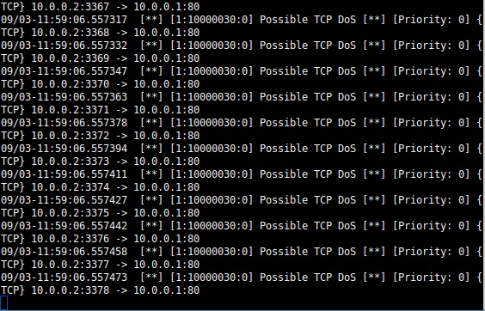

Figure 72 DoS Snort alerts

In order to confirm there is an issue, I check the controller’s monitoring statictics, to see any activity that is out of the ordinary. In Figure 73, I indeed see an increased number of bytes coming from Host 2 to Host 1, confirming that there is a flooding going on. Even though Figure 73 show information after the implementation of the mentioned firewall rule, the increased activity is clear.

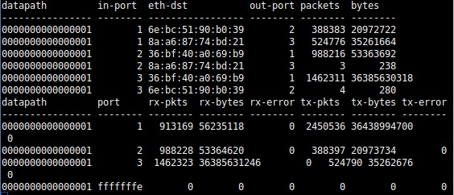

Figure 73 Statistics drawn from the controller after the implementation of firewall rule.

After confirming the attack, I measure the bandwidth from Host 3 to Host 1, using iperf. As seen on Figure 74, there is a decreased bandwidth, which means the flooding is affecting Host 1, the “server”, negatively.

|  |  |  |  |
| --- | --- | --- | --- |
| # Test | incoming bytes  (H2->H1) | Bandwidth  (H3->H1) | packet loss |
| Before | 245 | 8.26Gb/s | 0% |
| during | 20972kb | 5.03Gb/s | 0% |
| after | 53363kb | 9.04Gb/s | 0% |

Figure 74 Experiment total statistics

Finally, I can check Wireshark, seen in Figure 75, to see how a SYN DoS attack functions, before any rules are implemented. The goal of this attack is to force the target to send RST replies to all the stray SYN headers, making the flooded port unavailable for service.

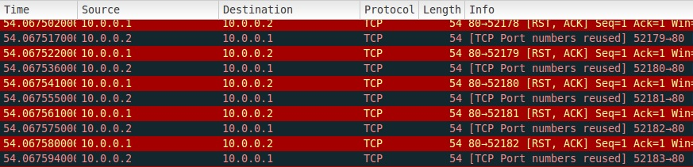

Figure 75 Wireshark DoS packet sniffing

In order to tackle the DoS attack, I will use iptables to implement a TCP specific rule.

In Host 1, I used the following command, which targets incoming TCP traffic from Host 2, towards Host 1 port 80:

iptables -A INPUT -p tcp -m tcp --dport 80 -s 10.0.0.2 -j DROP

Because malicious TCP packets can hit more than one ports, one can also block the entirety of incoming TCP traffic from a specific source address, or block multiple ports with the multiport attribute:

iptables -A INPUT -p tcp –s 10.0.0.2 -j DROP

iptables -A INPUT -p tcp -m multiport --dports 22,80 -s 10.0.0.2 -j DROP

After the mentioned rules are implemented, I measure the bandwidth between Host 3 and Host 1 again, noticing it has come back to normal, while byte count from Host 2 and Host 1 keeps increasing. This happens because packets from Host 2 keep going towards Host 1, since the attack has not stopped, but Host 1 does not send back any replies, hence not consuming its network resources.

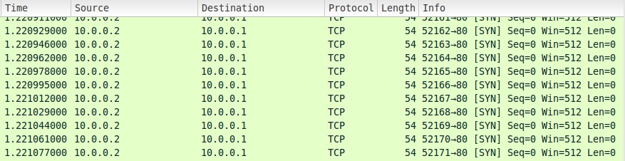

Figure 76 Wireshark sniffing after the rule is implemented

As you see in Figure 76, Host 1 keeps receiving flood packets from Host 2, but does not reply, therefore does not get clogged.

## 3rd case: Nmap port scans

For the last experiment, I perform a FIN port scan. To perform the scan, I utilized nmap. Nmap is a network scanner, with which can be used to scan networks and individual systems.

It should be noted that all port scan function in the same fashion, therefore I chose to show the results from one of them. Other types of scans could be an XMAS scan or NULL scan, like in previous experiments. Their purpose is to trigger an RST response from the targeted port and figure out if the port is open, filtered or closed.

In order to perform a FIN header scan, I utilized the following command, after installing nmap, which sends TCP packets with FIN flags to a big number of ports on the target:

nmap –sF –T4 10.0.0.1

After firing up Snort and the attack is initiated, alerts immediately start producing alerts, notifying us that a port scan has occurred, as seen in Figure 77.

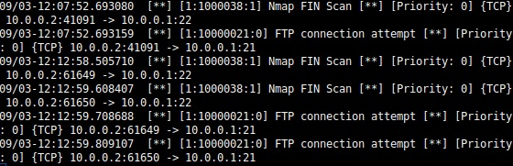

Figure 77 Snort alerts during a FIN port scan

When the alerts arrive, Ι start counter actions by checking the measurements from the controller. As seen in Figure 78, there is an increased byte activity from Host 2 to Host 1, indicating something minor happened.

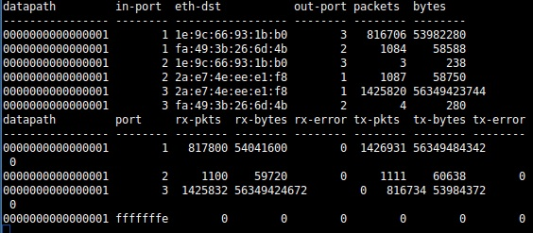

Figure 78 Measurements drawn from the controller

During the port scan, I also measured the bandwidth between Host 3 and Host 1, but the speed drop was not out of the ordinary, as seen in Figure 79. If it wasn’t for Snort, a network administrator wouldn’t be able to notice the scan.

|  |  |  |  |
| --- | --- | --- | --- |
| # Test | Incoming bytes  (H2->H1) | Bandwidth  (H3->H1) | Packet loss |
| Before | 230 | 9.17Gb/s | 0% |
| During | 58kb | 8.01Gb/s | 0% |
| After | 166kb | 9.01Gb/s | 0% |

Figure 79 Total measurements of this experiment

Wireshark can also give us an insight that a port scan occurred, by seeing Figure 80 with the packets it captured during the attack.

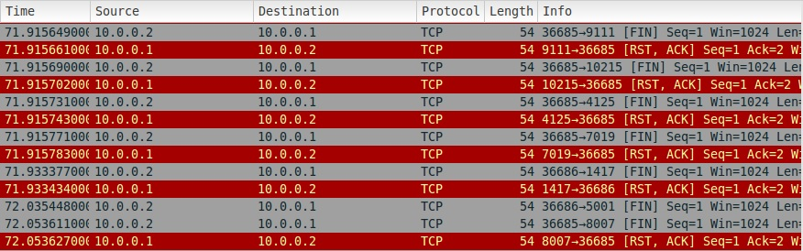

Figure 80 Wireshark port scan sniffing before rule implementation

Even though the activity was not important, when it comes to network load and clogging, it managed to give the attacker the information that port 5001, the port iperf is using to listen to requests on Host 1, is open/filtered, as seen in Figure 81.

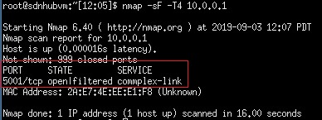

Figure 81 Port scan results before rule implementation

To counter the scan, I used the following firewall rule, which utilized the iptable’s tcp module to look for specific packet flags, FIN flags in this case, in packets going towards Host 1 (10.0.0.1) and drop them:

iptables -A INPUT -p tcp -m tcp --tcp-flags ALL FIN –s 10.0.0.2 -j DROP

Even though the rule is active, packets keep coming from Host 2 to Host 1, as seen in the “After” part of Figure 79. However, this is not an issue, because what the rule did is cut replies from Host 1 to Host 2, when it receives port scan packets with FIN headers. This can be seen in Figure 82, which is a Wireshark packet report showing a port scan on Host 1 from Host 2 after the rule was set. As you see, no replies are sent from Host 1 to Host 2.



Figure 82 Wireshark report after the implementation of the firewall rule.

Results are also visible on the attacker’s side. After setting the rule, and retrying the scan from Host 2, we get the result that all ports scanned at Host 1 are open/filtered, as seen in Figure 83.

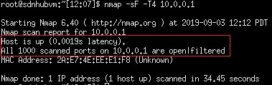

Figure 83 Port scan results after the firewall rule.

This way, the attacker and future attackers will be unable to “see” open iperf port,

and Host 1 will not be burdened with unnecessary TCP replies, no matter how minor they are.

* 1. Example 3: SnortIPS Program

For the last part of my experimentation, I will showcase the results of my Python script, which I implemented as a legacy IPS on an SDN infrastructure. The script’s purpose is to make the application of firewall rules more autonomous and direct for a network admin. In the following cases, you will see the same experiments as before, but with the usage of my script, meaning that the application of firewall rules happens as the “attacks” happen, with the exception of port scanning.

It should be noted that, in comparison with other experiments where I run Snort to monitor Host 1 from the switch’s interface “s1-eth1”, now the IPS is run locally on Host 1, utilizing the local interface “h1-eth0”. This is done so, when the IPS action of the script is triggered, firewall rules can be implemented successfully on the Host, since this cannot be done on the switch.

## 1st case: ICMP Flooding

Again, for the first experiment, I will conduct an ICMP packet flooding, from Host 2 to Host 1, while measuring the bandwidth between Host 3 and Host 1. Before I start my experiment, I set the “pingFlag” threshold to 10000, which is the number of alerts the IPS will be triggered after. This threshold is ideal for flood attacks, but not for smaller scale passive attacks. At the same time, the controller monitor has been fired up, giving us the packet and byte numbers of all existing connections. Then, I fired up the SnortIPS script on Host 1, and used hping3 to produce an ICMP flood from Host 2 to Host 1 with the following command:

hping3 –icmp 10.0.0.1 --flood

Immediately after the attack is initiated, SnortIPS starts showing us alerts about multiple ICMP packets coming in, before firing up the ICMP flood alert, as seen in Figure 84.

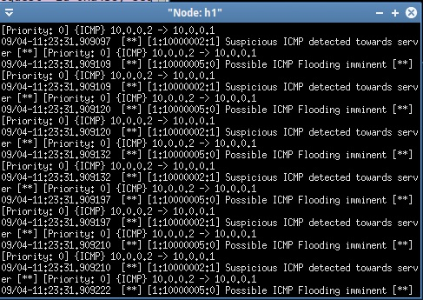

Figure 84 ICMP flood alerts on Host 1

While the IPS is sending us alerts, Ι check the controller monitor, in order to see if there is any extreme change in sent bytes from Host 2 to Host 1. Indeed, as seen on Figure 85, the controller shows us that Host 2 has sent 38236kb of information towards Host 1, before triggering the IPS.

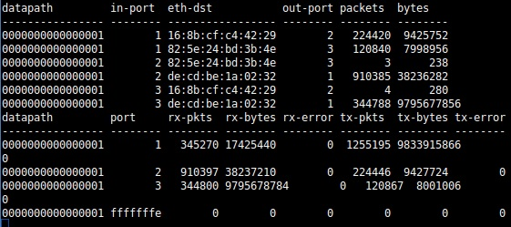

Figure 85 Controller drawn packet statistics

While the flooding is happening, I measured the bandwidth between Host 3 and Host 1, which has been dropped by 40%, making it obvious Host 2 is consuming network resources, as seen in Figure 86.

|  |  |  |  |
| --- | --- | --- | --- |
| # Test | Incoming bytes  (H2->H1) | Bandwidth  (H3-H1) | Packet loss |
| Before | 423b | 8.75Gb/s | 0% |
| During | 38236kb | 5.4Gb/s | 0% |
| After | 89856kb | 9.1 Gb/s | 0% |

Figure 86 Experiment total statistics

After the attack has been confirmed, I initiate the IPS function that was triggered by the IPS, by blocking all ICMP traffic on Host’s 1 interface. The IPS utilizes the following iptables command:

iptables -A INPUT -p icmp -i h1-eth0 -j DROP

After processing the last packets that were not affected by the firewall rule, Host 1 stops sending ICMP replies to Host 2, but keeps receiving its requests. However, this does not affect the network bandwidth, since Host’s 3 connection comes back to normal speeds, as seen in Figure 86 “After” test.

Since the application of the rule happens during the attack, you can clearly see the results before and after its effect on Wireshark, as seen in Figure 87.

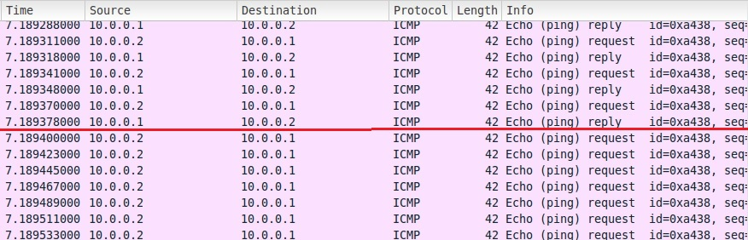

Figure 87 Wireshark captured packets the moment the rule is implemented

The red line in this Figure indicates the moment the firewall rule takes effect.

In order to cancel out the rule, after the attack is through, the administrator can either insert a canceling rule from the IPS’s manual insert function or use the CLI.

## 2nd case: TCP SYN DoS attack

In a similar fashion, I wanted to see how things will “roll out” with a TCP SYN flag packet flooding on port 80, from Host 2 to Host 1. This targets to simulate a DoS attack on said port, and how SnortIPS deals with it. This can be extremely useful, since a quick response to DoS attacks is essential, if the security policy that has been implemented requires the immediate counter response in such case.

It should be mentioned that in this case, my script does not react to the upcoming alert by a set a variable but, instead, compares the incoming alerts with a list of possible alert IDs, which would have been set by the administrator in a real case scenario, and this is how it reacts to the attack. This can be extremely useful, in case there is a set of rules which can be dealt with in the same manner.

Before I fire up the IPS, I set the “tcpFlag” variable, in the script, to 10000, which will be the alert threshold before the IPS function gets triggered and ask us for an action.

To simulate the attack, I used the following command, from Host 2, to send multiple TCP packets with SYN flag towards Host 1 port 80, while SnortIPS was monitoring its local interface:

Hping3 10.0.0.1 –p 80 –syn –flood

When the attack is initiated, I start getting alerts from Snort, on Host 1, about a DoS attack, as seen in Figure 88.

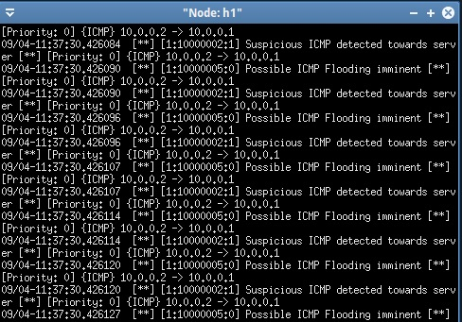

Figure 88 Snort alerts

After receiving multiple alerts, I check the controller drawn statistics about packet and byte count from Host 2 to Host 1, and see that there is indeed much information sent from one host to the other, as seen on the statistics in Figure 89.

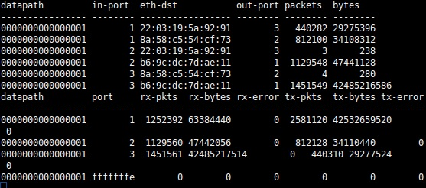

Figure 89 Controller drawn statistics

After seeing the out-of-the-ordinary bytes increase, I start measuring the bandwidth between Host 3 and Host 1 and see that there is a drop, as seen in Figure 90.

|  |  |  |  |
| --- | --- | --- | --- |
| # Test | Incoming bytes  (H2->H1) | Bandwidth  (H3-H1) | Packet loss |
| Before | 235b | 9.66Gb/s | 0% |
| During | 47441kb | 6.23Gb/s | 0% |
| After | 89681kb | 9.10 Gb/s | 0% |

Figure 90 Experiment statistics

After confirming there is actually an issue, I initiate the IPS function asked by the script. After the last packets that were not subjected to the firewall rule, implemented by the script, arrive on Host 1, I see that connection bandwidth between Host 3 and Host 1 comes back to normal, therefore I can ignore the increasing packets and bytes that keep coming from Host 2, as seen in Figure 90.

In Figure 91, you can see the attack’s captured packets on Wireshark, the moment the rule is implemented.

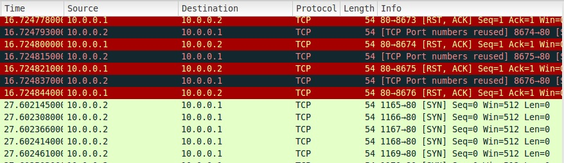

Figure 91 Wireshark captured packets

The reason why the network stopped getting clogged from the attack is because Host 1 stopped replying to Host’s 2 “stray” SYN packets, therefore no ports became unavailable.

## 3rd case: Nmap Scan

Finally, we reach the 3rd case, in which I experiment with the SnortIPS on a passive attack, a XMAS nmap port scan. I chose this specific attack because it specifically targets to go over firewalls and IPS systems, since some of those are not set to detect the headers used in the sent packets. To generate the scan, I used the tool “nmap” and the following command, which executes an XMAS scan on Host 1:

Nmap -sX -T4 10.0.0.1

Before starting SnortIPS on Host 1 and initiating the attack from Host 2, I set the threshold flag “nmapFlag” to 3, for the IPS function of the script to fire up after 3 alerts. This is done to deal with small scale attacks, usually passive ones that do not produce extraordinary amounts of bytes and packets.

After taking care of that, I fire up SnortIPS and initiate the attack. As seen in Figure 92, the IPS immediately starts showing us alerts when the port scan begins to send packets to multiple ports in Host 1, including the ones that have been included in my Snort alerts, eventually triggering the IPS.

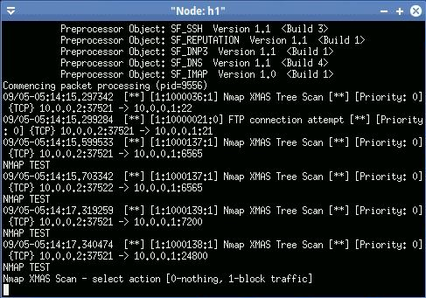

Figure 92 Snort alerts

At the same time I receive the alerts, I check the controller monitor, to see the packet and byte count that has been measured by the controller. Nothing is out of the ordinary, but the byte count from Host 2 to Host 1 is at around 58kb, which is a relative big change, considering Host 2 was not supposed to send data to Host 1, as seen in Figure 93.

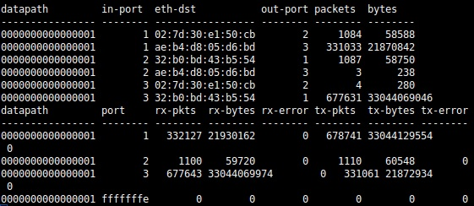

Figure 93 Controller drawn measurements

After seeing the alerts and the measurements, I measure the bandwidth between Host 3 and Host 1, using iperf, but see no significant drop, while the scan is initiated, as seen in Figure 94. If it wasn’t for the Snort alerts and the controller measurements, the attack would have happened without anyone noticing or being affected by it.

|  |  |  |  |
| --- | --- | --- | --- |
| # Test | Incoming bytes  (H2->H1) | Bandwidth  (H3-H1) | Packet loss |
| Before | 280b | 9.01Gb/s | 0% |
| During | 58kb | 8.32Gb/s | 0% |
| After | 160kb | 8.55 Gb/s | 0% |

Figure 94 Experiment statistics

While the attack does not affect the network, it does give the attacker the information that port 5001 is open/filtered in Host 1, which is true since iperf has set a server on it, to listen to requests. This can be seen in Figure 95.

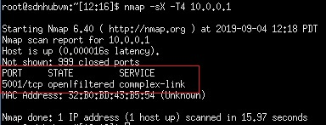

Figure 95 Port scan results before the implementation of the IPS action

After the attack has been completed, I initiate the IPS action, which sets the following iptables rule to block replies to TCP packets with FIN, PSH and URG headers from all sources arriving at Host’s 1 interface:

iptables -A INPUT -p tcp -m tcp --tcp-flags ALL FIN PSH URG –i h1-eth0 -j DROP

Indeed, if I initiate the action during a scan, you can clearly see the difference on Wireshark, the moment the replies are cut by the firewall rule, in Figure 96.

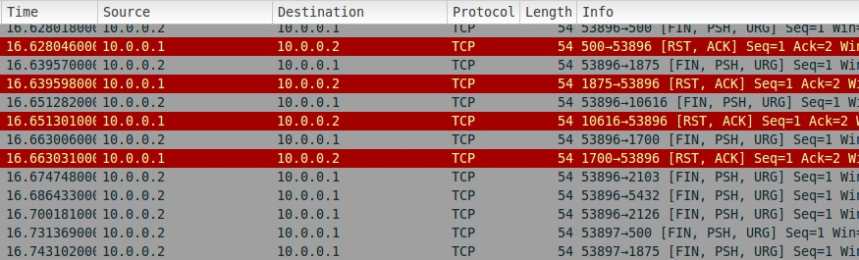

Figure 96 Wireshark packet capture

This has the result that the attacker can no longer see which port is open or closed, since his/her scanner will not be able to receive any replies anymore. Therefore, as seen on Figure 97, the scanner will show him that all ports that have been scanned are open/filtered.

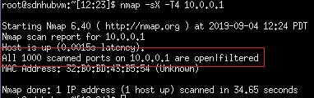

Figure 97 Nmap result after the IPS action

After the immediate action from the SnortIPS custom action, the administrator can delete the automated rule, which blocks replies to all incoming packets of that kind, and place his/her own, after receiving a specific IP from the Snort alerts, in order to set a new, more specific rule.

1. Conclusion

In conclusion, SDN can be a very redundant type of network, which is perfect for big infrastructures, like universities and data centers. It can offer amazing speeds, great manageability and programmability, while different QoS and security services can be implemented directly as a part of the infrastructure, not just “over” it, as an addition. Even though those strengths exist, what it has in speed and flexibility of use, it lacks greatly in security, with multiple extra vulnerable points, compared to legacy networks that can easily be exploited and are hard to monitor.

While there aren’t many options when it comes to security solutions specifically for that kind of networks, legacy networks have a strong arsenal of security solutions, especially on the application layer, which could be integrated on an SDN network, making the usage of those tools a viable solutions.

After experimenting with the legacy tool Snort, a open-source legacy IDS software, and iptables, the default Linux software for setting firewall rules, I have concluded that this kind of tools not only can be integrated effectively in SDN, but they can also benefit any infrastructure of that kind in a techno-economical manner, by creating a cost-effective security solution, especially on a big scale.

Performing an array of attacks inside my SDN infrastructure, while using Snort and iptables, I measured the bandwidth fluctuations and byte counts to confirm there was a benefit from those two tools. Using Snort, I was able to detect any attack, successfully, and restrict it using iptables. From the changes in bandwidth, I double-checked that any attack will affect the network’s bandwidth but, as long as the mentioned security tools are used, everything comes back to normal.

While Snort can be a strong tool to detecting attacks, it greatly burdens the SDN network, reducing the total bandwidth greatly, as some experiments showed.

Nevertheless, it is an essential tool, whose drawbacks can be overcome with a strong network connection and powerful hardware.

As a rewind of this thesis, I start with a theoretical part, where describe how SDN works, its history and the different parts that comprise an SDN infrastructure and in addition to all that, I went into more detail about how many controllers there are out there. This makes SDN a very versatile and open infrastructure that anyone can get into and create his /her own thing. Later, for comparison, I went into more detail about legacy networks, their protocol layers, how security can be implemented into them and what types of attacks they can be vulnerable to, before transcending to security in SDN, a sector where SDN clearly lacks in power and solid solutions, in comparison to legacy networks. Finally, I executed experiments on a virtual SDN environment, where I integrated legacy network tools effectively in my SDN infrastructure.

All an all, this project showed a lot of great results, which were not taken lightly and will be used for future reference.

1. References

[1] Network Innovation through OpenFlow and SDN: Principles and Design, by Fei Hu

[2] <https://en.wikipedia.org/wiki/Software-defined_networking>

[3] <https://en.wikipedia.org/wiki/OpenFlow>

[4] Software-Defined Networking: A Comprehensive Survey, by Diego Kreutz, Ramos, Paulo Verissimo, C. E. Rothenberg, S. Azodolmolky, S. Uhlig

[5] SDN: Software Defined Networks, by Ken Gray, Thomas D. Nadeau

[6] <https://www.sdxcentral.com/networking/sdn/definitions/southbound-interface-api/>

[7] <https://wiki.onosproject.org/display/ONOS/OpenFlow+1.5+Implementation>

[8] [Introduction to OpenFlow, video by David Mahler](https://www.youtube.com/watch?v=l25Ukkmk6Sk)

[9] <https://searchnetworking.techtarget.com/definition/SDN-controller-software-defined-networking-controller>

[10] <https://www.sdxcentral.com/networking/sdn/definitions/sdn-controllers/>

[11] <http://mininet.org/overview/>

[12] <https://en.wikipedia.org/wiki/Open_vSwitch>

[13] <https://www.openvswitch.org/>

[14] <https://en.wikipedia.org/wiki/Open_vSwitch>

[15] <http://www.projectfloodlight.org/floodlight/>

[16] <https://www.sdxcentral.com/networking/sdn/definitions/what-is-floodlight-controller/>

[17] <http://yuba.stanford.edu/~nickm/papers/p105-v38n3u-mckeownA4.pdf>

[18] <https://noxrepo.github.io/pox-doc/html/#openflow-in-pox>

[19] <https://ryu.readthedocs.io/en/latest/getting_started.html>

[20] <https://osrg.github.io/ryu/>

[21] Network Security Essentials: Applications and Standards (3rd Edition), by William Stallings

[22] <https://en.wikipedia.org/wiki/OSI_model>

[23] <https://medium.com/@selmanb/osi-model-a-concept-that-not-only-techies-need-to-know-about-f5067b8538e5>

[24] <https://www.networkworld.com/article/3239677/the-osi-model-explained-how-to-understand-and-remember-the-7-layer-network-model.html>

[25] <http://chettinadtech.ac.in/storage/15-07-01/15-07-01-09-22-26-3255-senthil.pdf>

[26] <https://www.geeksforgeeks.org/types-of-security-attacks-active-and-passive-attacks/>

[27] <https://en.wikipedia.org/wiki/Network_security>

[28] <https://en.wikipedia.org/wiki/Idle_scan>

[29]<https://www.tutorialspoint.com/network_security/network_security_firewalls.htm>

[30]<https://en.wikipedia.org/wiki/Intrusion_detection_system#Intrusion_prevention>

[31] <https://www.quora.com/What-is-the-difference-between-security-service-and-mechanism>

[32] <https://eezytutorials.com/Cryptography-And-Network-Security/Security-services-and-mechanisms.php#.XNmL96RjShc>

[33][https://en.wikipedia.org/wiki/Security_service_(telecommunication)](https://en.wikipedia.org/wiki/Security_service_(telecommunication)#Specific_security_mechanisms)

[34] <https://www.w3.org/TR/ws-gloss/>

[35] Intrusion Detection System, By Argyris Koudounas, Christos Markelos, Nikolaos Parashos ([link](https://mega.nz/#!fwJ30AiB!6ZcB20pOFuiNSXr8RpQEHHQo9wEhy5-IHjLTui2aDGg))

[36] Security in Software Defined Networks, by Talal Alharbi ([link](https://tinyurl.com/y5abu8zn))

[37] Quick Look: Security Risks in SDN and Other New Software Apps ([video](https://www.youtube.com/watch?v=jTHiBw4tJIM))

[38] Securing The SDN Northbound Interface, by Jan J. Laan ([link](https://www.delaat.net/rp/2014-2015/p73/report.pdf))

[39] <https://en.wikipedia.org/wiki/VMware_Workstation>

[40] <http://sdnhub.org/tutorials/sdn-tutorial-vm/>

[41] <https://en.wikipedia.org/wiki/Snort_(software)>

[42] <https://en.wikipedia.org/wiki/Iptables>

[43] <https://www.sdxcentral.com/networking/sdn/definitions/north-bound-interfaces-api/>

[44] <https://upcloud.com/community/tutorials/install-snort-ubuntu/>

[45] <http://sublimerobots.com/2016/02/snort-ips-inline-mode-on-ubuntu/>

[46] Snort User Manual ([site](http://manual-snort-org.s3-website-us-east-1.amazonaws.com/))

[47] <http://mininet.org/download/>

[48] <https://www.booleanworld.com/depth-guide-iptables-linux-firewall/#Targets>

[49] <http://mininet.org/walkthrough/#part-1-everyday-mininet-usage>

[50] <http://sdnhub.org/tutorials/ryu/>

[51] <https://www.pythonforbeginners.com/systems-programming/how-to-use-the-pexpect-module-in-python>

[52] <https://pexpect.readthedocs.io/en/stable/index.html>

[53] <https://github.com/vidhiJain/ryu_application>

[54] <https://whatismyipaddress.com/port-scan>

[55] <https://en.wikipedia.org/wiki/Ping_flood>

[56] <https://en.wikipedia.org/wiki/Denial-of-service_attack>

1. Table of Figures

Figure 1 SDN Structure and functionality 11

Figure 2 OpenFlow Switch Components [7] 13

Figure 3 A software defined network example [8] 14

Figure 4 Mininet Logo [11] 16

Figure 5 A visualization of a simple Mininet Network [5] 17

Figure 6 Open vSwitch deployed as a cross-server network switch [14] 18

Figure 7 Floodlight SDN architecture [15] 19

Figure 8 NOX architecture [5] 20

Figure 9 Entirety of Ryu components [5] 21

Figure 10 The 7 layers of OSI model [23] 22

Figure 11 The OSI security architecture [25] 24

Figure 12 An example of an idle scan, using a “zombie” pc [28] 25

Figure 13 An example of how a "Man in the middle" active attack works 26

Figure 14 Security Services, according to X.800 [27][32] 27

Figure 15 Security mechanisms, according to X.800 [27] 28

Figure 16 IDS set-up structure 30

Figure 17 Comical network partitioning by a firewall [29] 31

Figure 18 SDN Security Vector Map [37] 33

Figure 19 VMware Logo [39] 38

Figure 20 SDN Hub Logo [40] 39

Figure 21 Snort IDS/IPS Logo 39

Figure 22 VMware Workstation Home Screen 41

Figure 23 Rules structure 46

Figure 24 Rule Structure 46

Figure 25 Rule options part 47

Figure 26 Inline mode network configuration 50

Figure 27 Snort DAQ Libraries 50

Figure 28 snort.conf Inline mode configuration 50

Figure 29 Inline mode test rule set 50

Figure 30 Snort console network monitoring command 51

Figure 31 Snort default start screen 51

Figure 32 Alerts produced by Snort, according to our rule set 51

Figure 33 Mininet basic command and "pingall" command 53

Figure 34 Rule chain datagraph 57

Figure 35 FTP server control through Pexpect [51] 60

Figure 36 A section in the script, discovering 1 specific rule. 61

Figure 37 Bulk rule trigger structure 61

Figure 38 Script threshold flags and rule SID lists 61

Figure 39 Choice structure of firewall control. 62

Figure 40 SnortIPS starting screen 62

Figure 41SnortIPS interface selection 63

Figure 42 SnortIPS firewall options 63

Figure 43 Ryu Simple Monitor Statistics 64

Figure 44 Custom Snort rules example 64

Figure 45 Single and Linear topology examples on MiniEdit 65

Figure 46 ICMP Flooding alerts 66

Figure 47 Packet statistics from the Controller 66

Figure 48 ICMP Flooding Statistics 67

Figure 49 ACK flooding alerts 67

Figure 50 Statistics shown by the controller monitor 67

Figure 51 ACK attack statistics 68

Figure 52 ACK Flood Wireshark results 68

Figure 53 Controller monitor statistics 69

Figure 54 Dos attack statistics 69

Figure 55 DoS attack Snort alerts 70

Figure 56 DoS packet composition on Wireshark 70

Figure 57 XMAS Scan Snort alerts 71

Figure 58 Statistics drawn by the controller after a XMAS scan 71

Figure 59 Total statistics 71

Figure 60 XMAS Scan Wireshark sniffing 72

Figure 61 XMAS scan results 72

Figure 62 NULL scan alerts 72

Figure 63 Statistics drawn from the controller after a NULL scan 73

Figure 64 NULL Scan statistics 73

Figure 65 NULL scan Wireshark sniffing 73

Figure 66 NULL Scan results 74

Figure 67 Snort alerts during ICMP flood 74

Figure 68 Statistics drawn by the controller during the attack 75

Figure 69 ICMP flood test total statistics 75

Figure 70 Wireshark ICMP flood before implementing firewall rule 75

Figure 71 Wireshark report after the implementation of firewall rule 76

Figure 72 DoS Snort alerts 77

Figure 73 Statistics drawn from the controller after the implementation of firewall rule. 77

Figure 74 Experiment total statistics 77

Figure 75 Wireshark DoS packet sniffing 78

Figure 76 Wireshark sniffing after the rule is implemented 78

Figure 77 Snort alerts during a FIN port scan 79

Figure 78 Measurements drawn from the controller 79

Figure 79 Total measurements of this experiment 79

Figure 80 Wireshark port scan sniffing before rule implementation 80

Figure 81 Port scan results before rule implementation 80

Figure 82 Wireshark report after the implementation of the firewall rule. 80

Figure 83 Port scan results after the firewall rule. 81

Figure 84 ICMP flood alerts on Host 1 82

Figure 85 Controller drawn packet statistics 82

Figure 86 Experiment total statistics 82

Figure 87 Wireshark captured packets the moment the rule is implemented 83

Figure 88 Snort alerts 84

Figure 89 Controller drawn statistics 84

Figure 90 Experiment statistics 84

Figure 91 Wireshark captured packets 85

Figure 92 Snort alerts 86

Figure 93 Controller drawn measurements 86

Figure 94 Experiment statistics 87

Figure 95 Port scan results before the implementation of the IPS action 87

Figure 96 Wireshark packet capture 87

Figure 97 Nmap result after the IPS action 87